Literature Review: Assignment I

1472 EDTC 810 Statistics for Ed Research

New Jersey City University

Kerry Magro M. A.

March 2018

First Revision

TABLE OF CONTENTS

ARTICLE I DISCUSSION Pages 3-8

Article II DISCUSSION 8-14

REFERANCES________________________________________________________________15-16

AppendIX A 19-23

The Nation’s Report Card: Arts Assessment 2016 Overview

APPENDIX B 23-27

Wiley Online Library:

Comparison between Medical Students’ Experience, Confidence and Competence

TABLE OF CONTENTS

ARTICLE I DISCUSSION Pages 3-8

Article II DISCUSSION 8-14

REFERANCES________________________________________________________________16-17

AppendIX A 18-23

The Nation’s Report Card: Arts Assessment 2016 Overview

APPENDIX B 23-29

Wiley Online Library:

Comparison between Medical Students’ Experience, Confidence and Competence

**Article I: The Nation’s Report Card: Arts Assessment 2016**

**Overview of Article I**

Since 1969 Congress has mandated that U.S. students educational progress be assessed. Administered by the National Center for Education Statistics (NCES) operating in the US Department of Education (USDOE) the (NCES) performs a National Assessment of Educational Progress (NAEP) annually and publishes statistical reports through media outlets and pressroom on the status of education in the United States.

**NAEP Analysis**

The article, “The Nation’s Report Card, Art Assessment 2016 “ was done in 2016 and published online in the sites’ pressroom measured the knowledge and skills of the visual arts of nearly 8,800 eighth-graders nationwide in public and private schools. The Arts assessment was broken down into two categories of music and visual arts. The three components of the assessment are indicated in an infographic done by The Nation’s Report Card as shown in Table 1(2016).

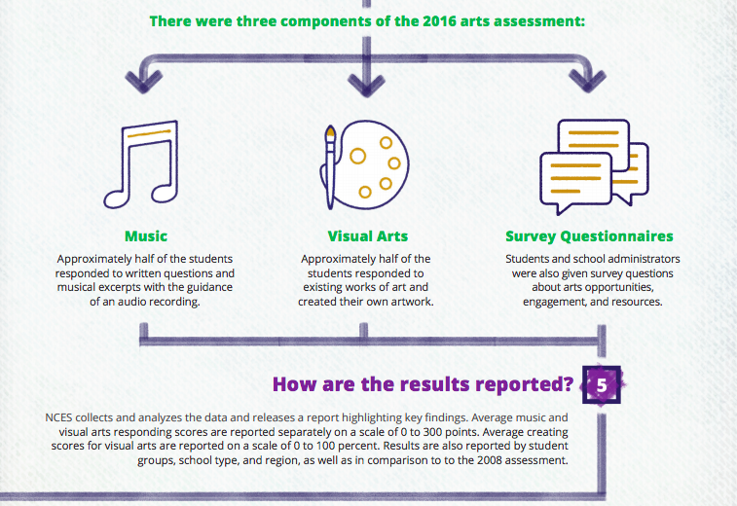

**Table 1 (NAEP 2016)**

The type of assessment consisted of surveys (where much of the demographic information was taken from), in person responses from students and creating their own artwork. The results of this 2016 assessment were compared to a previous assessment of 8th graders that was conducted in 2008. The assessment overall took just about 120 minutes for each student to complete and were completely confidential based on the actual assessment of each individual students’ score. The test was administered by representatives from the NAEP at the student’s school either by paper and pencil or computer based. The data was then collected and scored for all 8,800 eighth graders at selected public and private schools. The article did not go into it in detail but the website explains thoroughly the authorizing legislation, the sampling process and construct nationwide, <https://nces.ed.gov/nationsreportcard/about/samplesfaq.aspx#how_selected> (NAEP 2016)

The data as presented in the report sorted the survey to collect data from both students and administrators in each school. In particular the students demographic information was collected, and relevant indicators such as students eligible for free lunch which is an economic indicator, and English as a Second Language (ESL) and disability were correlated to student responses for the 2016 survey.

**Conclusions**

Some of the key takeaways from the 2016 assessment of 8th graders included that, on average, female students scored higher than male students, that students from suburban schools scored higher than those in urban or city schools and students in private scored higher than those in public schools. Demographic and race ethnicity subsets were calculated showing gaps and geographic location affect on score results. For example, Hispanic students scored much higher in 2016 versus the 2008 assessment. Indicators were presented as to scoring. Visual Arts scale was done through a 0-100 percentile. Two types of questions were asked responding and creating only responding results were scored based on 0-300.

While the assessment was important to continue the focus of the arts we should continue to see follow up from the NAEP as this assessment evolves. The authors of the assessment acknowledged that the scores were not much different between 2008 and 2016 but indicated that more arts are needed as only 63% of eighth-graders actually took a music class and only 42% took an art class in 2016.

**Strengths**

The strengths of this analysis were a continual buy in from 1996 by the NAEP to continue this assessment over time. Long-standing assessment tool with comprehensive sampling lends legitimacy to the test results. Familiarity with the arts both in and outside of class was an indicator of exposure to programs in the community. In addition a strength that was clear was the diversity of the students actually assessed as in the sample of students included both students with disabilities and English language learners along with those from different school environments, race and gender.

**Weaknesses**

The article did not comprehensively outline many of the issues noted below. Weaknesses that could be gleaned from the article include that even though all students were given the surveys to complete that they didn’t complete all the components of the assessment when it came to music and visual arts. There was a note that the assessment had to be completed by at least 70% of students’ in each school involved. An argument can be made for bias based on the rest of the student body’s actual involvement. As students are selected at random, it’s hard to predict whether or not the actual assessment has a fair standing when it comes to the actual results. Another weakness was there was no overall art score assigned breaking out into visual arts and music that may represent different “art” skill sets. As for the testing/assessment **t**here was no information in the article on

* How the schools were selected
* How were the students selected
* What was the sample size
* Any statistical variation applied to the results
* Any reliability and confidence indicators applied to the results
* Does the assessment represent the rest of the students in the country
* Can the results be generalized to the rest of the students
* Was permission needed from the parents to be assessed
* Would the students or parents be allowed to opt out and how would that affect the participation rate needed for the study

**Points for consideration**

The existence of this type of comprehensive data assessment on the National and State level is an invaluable tool and resource for educators. Consideration should be given to answering the questions raised above as to the process of selection of the sample and related questions on parent awareness and buy in as well as additional information on different testing strategies for English as a Second Language learner and students with disabilities. The results of this type of assessment can be used by policymakers and grant funders to micro target specific groups to enhance the learning opportunities for these students.

**Article II: Morgan & Cleve-Hogg**

After finishing a quantitative study that examined medical students experience confidence and competences, Morgan and Cleave-Hogg published the study findings in Medical Education Journal (2002) titled “Comparison between Medical Students Experience, Confidence and Competence “. The Blackwell Science Ltd published this and I retrieved/purchased it from the Wiley Online Learning Library.

**Overview of Article II**

The purpose of the research was to help medical students. Previous studies indicated students did not have enough exposure to solving real world clinical problems they required to become good doctors. An example note was while students observed anesthesiologists in the operating room during rotations they could not administer anesthesia until they were certified as doctors (Morgan & Cleave-Hogg 2002). At the University of Toronto this study was designed to see if the students’ medical experiences, levels of confidence would improve their overall competency in this and other medical competencies. The purpose of the study was to examine the relationship between these factors: experience and confidence and examine its relationship to performance on competency tests which were conducted in simulators.

**Morgan & Cleve-Hogg Analysis**

Following research protocol IRB permission was obtained from the University of Toronto. 177 final year medical students were invited to participate at a one-day workshop at the University of Toronto Anesthesia Simulation Center. At the workshop they were asked to complete a structured questionnaire with questions on their experience and how confident they were about their ability. The format of the questionnaire used Likert type questions using 5 to indicate they felt they were experts and 1 to indicate they were new to the task. Examples: Did they ever take blood, emergency management? Data was analyzed using Spearman rank correlations, A P-value of <0.05 was significant. The 25 questions were supplemented by questions required they quantify how many times they had either done a task or been exposed to a scenario. They were asked to give an absolutely # to as the # of times they did a procedure.

Each of the subjects has had clinical exposure for one week to anesthesia in the operating room although they could not administer it directly. Before participating in the session. The University has a high end simulator which is used as an educational tool where critical events can be practiced without effecting patient safety. After each of the survey tasks were completed they were asked to go into the simulator and perform a simulated task for a period of 5 minutes. In the simulator they were given three tests and were graded at the end of the sessions and each session was videotaped for future learning opportunities**.** 177 students in a medical education program were asked to participate in an education workshop to complete a questionnaire N=144. 144 responded and attended. These students (N=144) were asked to complete a 25-point questionnaire on their confidence with handling patient problems based on their clinical experiences. A P value of <0.05 was considered significant. Level of confidence data was compared to clinical rotation and marks in final evaluation. Prior experience and level of confidence and management of skills and clinical problems were collected for correlation with test results. The number of times they had performed a task were required to establish baseline data. After the attempt at cluster sample was completed they were introduced to the anesthesia simulator. A faculty member then scored their performance in the operating room/simulator for 5 minutes.

**Results**

The test results of the structured survey were clearly identified in the study by figures and tables. The study was conducted by convenience sampling moving towards cluster sampling with the 177 medical student invited and 144 responded. There was a 81% participation rate (177) and workshop attendees (n=144) who answered the questionnaires .had a response rate of 100%

The report summarized the findings in two tables as shown **: (**Morgan & Cleve-Hogg 2002)

**Table 2** of the study as shownidentified the correlation of the number of times a skill has been performed with level of confidence

**Table 3** of the study as shown there was a non-significant correlation between the three factors, # of times the skill had been performed, the level of confidence and the simulator test scores

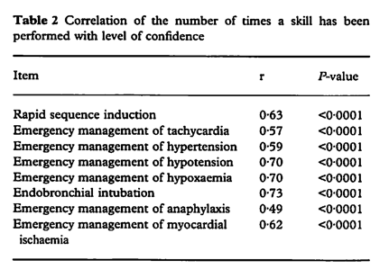

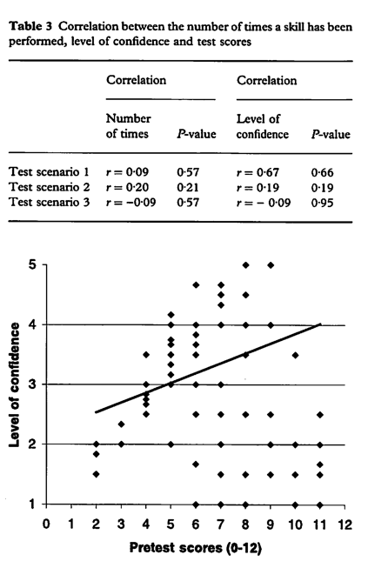

**Table 3 Correlation between the number of times a skill has been performed level of confidence and test**

**Table 2** of the study as shownidentified the correlation of the number of times a skill has been performed with level of confidence

**Table 3** of the study as shown there was a non-significant correlation between the three factors, # of times the skill had been performed, the level of confidence and the simulator test scores

**Table 3** there is a low correlation except for Test scenario 1 where # of times and level of confidence showed correlation.

Pretest scores were tightly recorded forming a line together

**Table 3** number suggests the # of time skills performed do not relate to performance on the competency scores in the simulator.

**Findings**

* The students had a wide range of experiences pretest varying from 1-100.
* The number of times skills performed evokes more confidence but does not necessarily affect competency and is not based the number of times a skills performed.
* Results indicate the number of times you perform a test may make you more confident but you still need to study for a competency test.

**Strengths**

* High participation rate probably meaningful 100% return.

**Weakness**

* There was no correlation between experience pretest and results
* Test may not be valid
* Number of times skills performed lead to more confidence but do not necessarily affect

competency.

* Other indicators may need to be studied including the relevance of the performance assessment
* Question of whether assessment is valid
* Questions at to whether results can be generalized
* Question as to whether more experience in the field is needed to even examine this question
* Whether simulator test is too difficult
* Lack of familiarity with testing in simulator was a factor

**Conclusion – Compare/Contrast & Analysis**

The two articles both shared some similarities and differences. As part of the assignment one of the main differences was that Assessment I was media focused and Article II was journal based. Similarities of the assessments include...

* Both were assessments of ability (confidence).
* Both were structured surveys using a questionnaire to receive data.
* Ethics were maintained throughout both assessments,

The differences from both the articles included…

* Rates of completion - NAEP only 71% completed while all the medical students 100% completed there’s that were distributed.
* Age and degree levels - One of the assessments was completed by eighth-graders while the other assessment was comprised of medical students.
* According to the NAEP website, their assessment was randomized extensive sampling while the other assessment was convenience sampling. Attempting cluster sampling
* While the NAEP assessment has been completed several times over the years and there for could offer comparative value there was no indication that the other one was.
* Questions were developed in Assessment I while the questions in Assessment II had to be taken from the University of Toronto.

Overall, I found this assignment very helpful on how we look at statistics in literature. It made me look back at the beginning of the semester and reading our syllabus when in the Catalog description it stated that we would be able to better understand “evaluating statistics from various sources.” I found that this assignment did just that and for that I’m grateful to have taken a part in this assignment As to doing things differently I have identified in each weakness section suggestive next steps if the study were to re- tooled or re programmed.

**References**

Evaluation of NAEP (PDF) - Home | U.S. Department of Education. (n.d.). Retrieved March 26, 2018, from https://www.bing.com/cr?IG=16817943D0444C1EB4A9832FEEEBAE87&CID=165BCCED73A8649E039CC75372076503&rd=1&h=kUuPVJM98CjZUBQTJwtGCJ8PoSCrNPDFeCs0E1FNRsM&v=1&r=https://www2.ed.gov/rschstat/eval/other/naep/naep.pdf&p=DevEx,5163.1

Morgan, P. J., & Cleave-Hogg, D. (2002). Comparison between medical students experience, confidence and competence. *Medical Education,* *36*(6), 534-539. doi:10.1046/j.1365-2923.2002.01228.x

NAEP - 2016 Arts Assessment. (n.d.). Retrieved March 26, 2018, from https://www.nationsreportcard.gov/arts_2016/

NAEP State Assessment Sample Design Frequently Asked Questions. (n.d.). Retrieved March 26, 2018, from <https://nces.ed.gov/nationsreportcard/about/samplesfaq.aspx#how_selected>

*Statistics for People Who Think They Hate Statistics Study Guide for Psychology to Accompany Salkinds Statistics for People Who Think They Hate Statistics, 6th Ed. Stats for People Who Think They Hate IEB, 6th Ed*. (2016). Sage Pubns.

The NCES Fast Facts Tool provides quick answers to many education questions (National Center for Education Statistics). (n.d.). Retrieved March 26, 2018, from https://nces.ed.gov/fastfacts/display.asp?id=900

**Appendix I: Media Article**

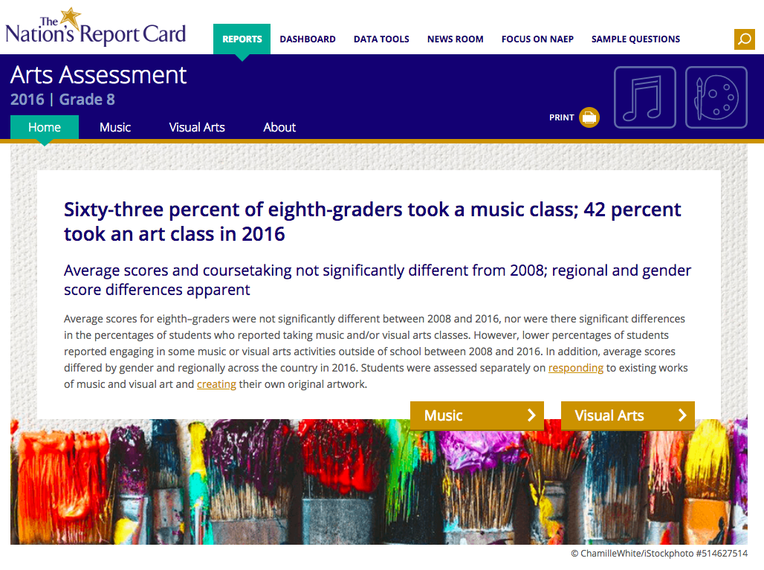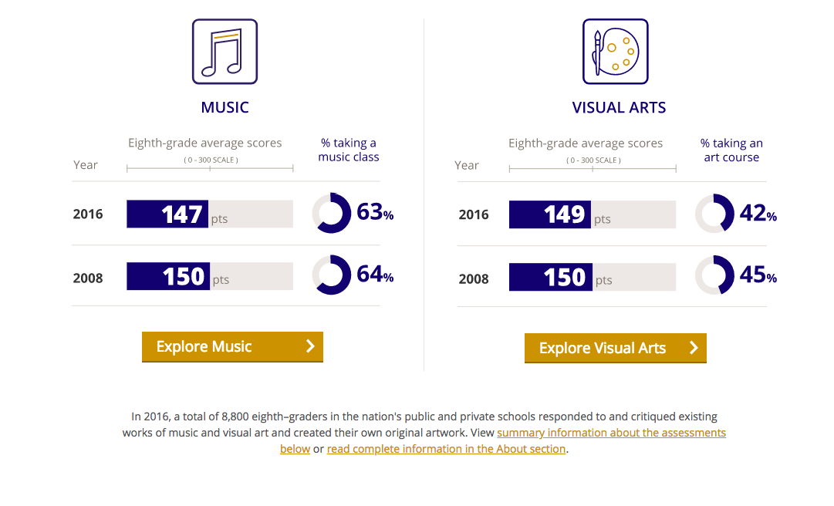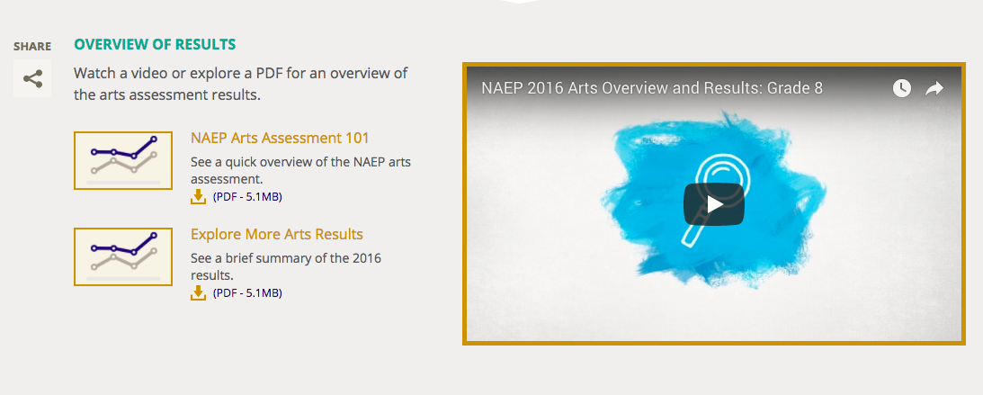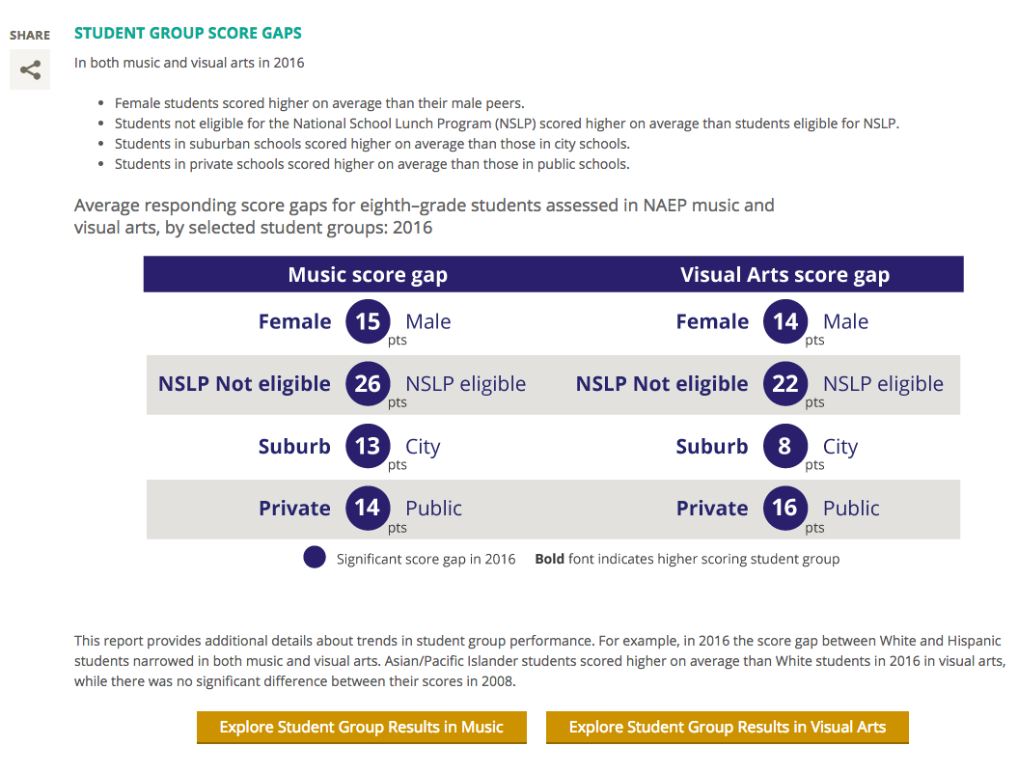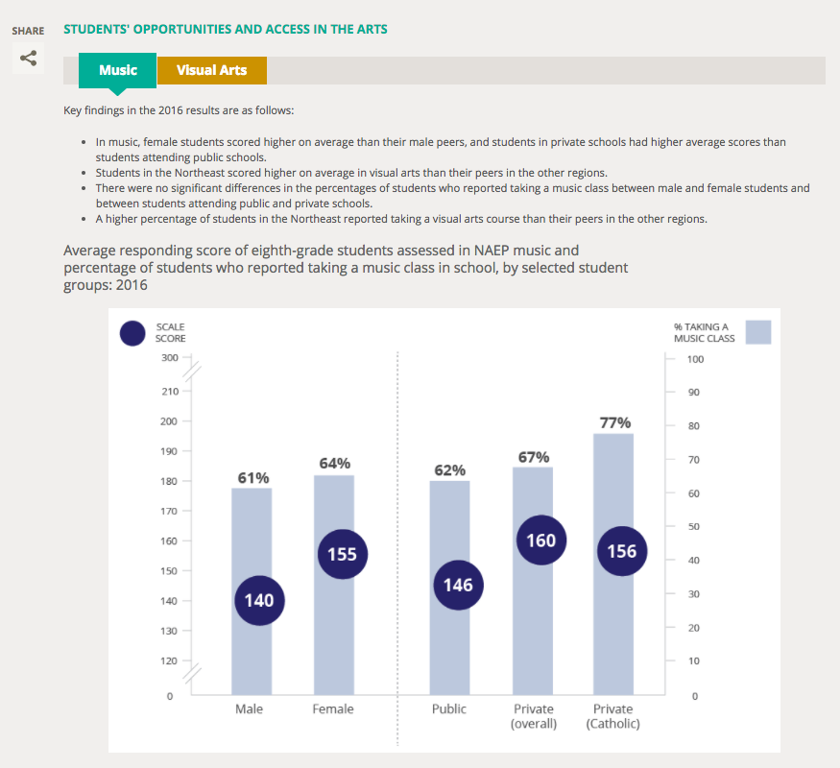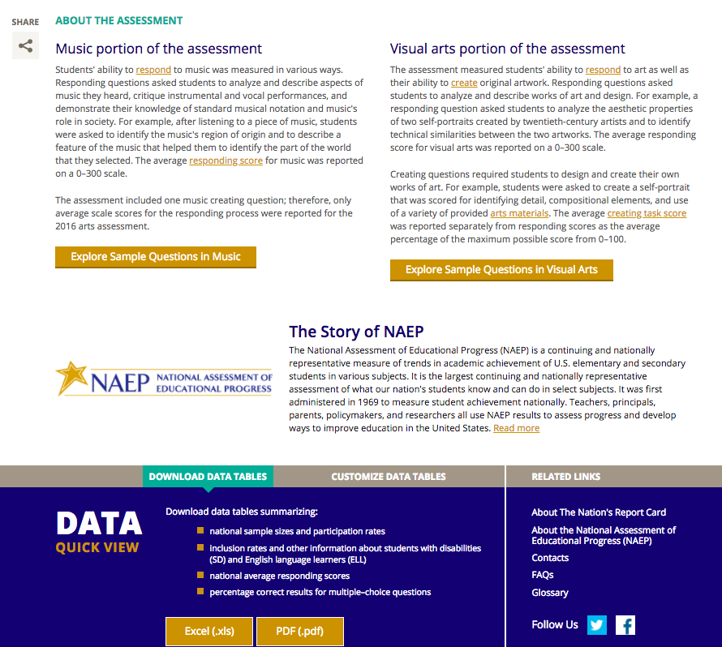

**Appendix II: Scholarly Article** 