Statistical Analysis of 4th Grade Reading Scores Across Ethnicity

New Jersey City University

EDTC 810 Statistics for Educational Research

Project 4

Spring 2018

Kerry Magro

**Introduction to Analysis**

The National Assessment of Educational Progress (NAEP) looks at the performance of students in a fourth, eighth and twelfth-graders in the United States. As part of the NAEP that is administered by The National Center for Education Statistics (NACES), they publish an ongoing Nation’s Report Card (NRC) which looks at both the reading and mathematics levels of students both in public and private schools. According to The Nation’s Report Card website the National Center for Education Statistics (NCES) operates within the United States Department of Education and Institute of Education Sciences (IES) under congressional mandate.

While the assessments administered started in 1969, the first actual reading and mathematics assessments started in 1992. Since then it has been conducted 13 times with the last results published for the assessment in 2015. In 1998, the assessment granted accomodations for the first time for ESL students and students with learning disabilities providing greater access to representation by these groups.

The data was scored in 2015 with a range of 0-500 for each student. Initial results indicated that grade 4 reading was similar to it’s 2013 numbers even though there was a slight increase. The sample of students who end in the results consist of public schools, private schools, Bureau of Indian Education schools and Department of Defense schools.

The Nation Report Card indicates that Hispanics are the fastest growing segment of the population. Further the US Census Bureau Reports of the 325,719,178 residents were reported and 17.8 % of them are Hispanic (See Appendix II).

Note: After this analysis was conducted in late April early May 2018, the NAEP came out with their numbers for the 2017 Nation’s Report Card. Future analysis should be conducted on this data set in comparison to the 2017 findings.

**Data Set**

The analysis is conducted using the data from 2015 Nation’s Report Card Reading Assessment for the fourth grade. The data set can be found in Appendix 1 of this paper. It represents the results from 50 states and the District of Columbia. As part of the assessment the average scale scores were looked at based on the ethnicity of the students..

From this data set the categorical variables that will be looked at are State and Ethnicity.

In addition the quantitative variables that will be looked at include the average scale scores for white, black and hispanic 4th grade students.

**Hypothesis**

Hypotheses are predictions of the outcome of a study which can be proved or disproved by the examination of variables in a study. The following hypothesis was examined for this test.

**Null Hypothesis:**  : Hispanic students on average score the same as white students on the 2015 nation’s report card.

**Alternative Hypothesis: :** Hispanic students on average do not score as well as white students on the nation’s report card.

**Descriptive Statistics**

Table 1 presents an overview of the numbers that were looked at as part of this analysis. Table 1 represents the White-average scale scores, Black-average scale scores, and Hispanic-average scale scores for 4th grade students.

|  |  |  |  |
| --- | --- | --- | --- |
| Average-scale scores | Whites | Blacks | Hispanics |
| N | 50 | 42 | 48 |
| Mean | 231 | 206 | 209 |
| Median | 231 | 205 | 210 |
| Standard Deviation | 4.86 | 6.74 | 5.85 |
| Minimum | 217 | 192 | 199 |
| Maximum | 242 | 217 | 224 |

**Table 1: Descriptive Statistics on Average Scale Score by Ethnicity**

As you can see from Table 1 there were more states scored for whites vs blacks and Hispanics. The report is as follows...

White - (**N** = **50, MEAN=231, MEDIAN=231, STDEV=4.86, MIN=217, MAX=242)**

Black - (**N** = **42, MEAN=206, MEDIAN=205, STDEV=6.74, MIN=192, MAX=217)**

Hispanic - (**N** = **48, MEAN=209, MEDIAN=210, STDEV=5.85, MIN=199, MAX=224)**

The states that were exempt for blacks were Hawaii, Idaho, Montana, New Hampshire, New Mexico, Oregon, Utah, Vermont and Wyoming. The states that were exempt for Hispanics were Maine, Vermont and Wisconsin.

More uniform capturing of student ethnicity data on the state level is an area that should be considered as an improvement for NAEP for future report cards.

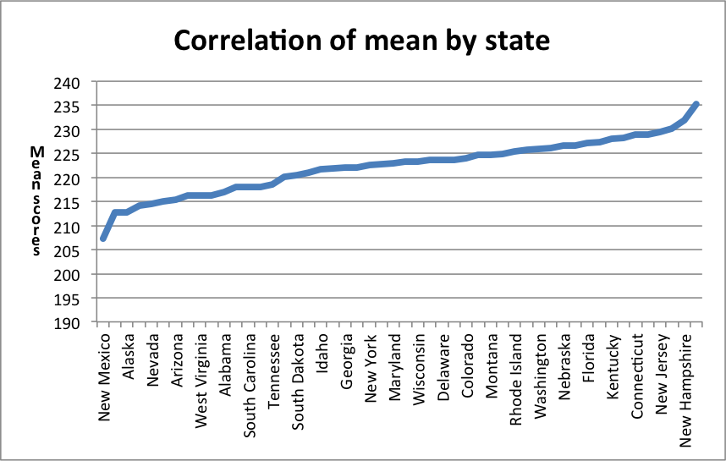

**Table 2: Correlation of mean by state**

The average mean score for each individual state is indicated in the chart above. Although it’s hard to get an accurate visual based on some states not having all the ethnicities participate it can be shown here that New Mexico **(207)** has the lowest average-scale score while New Hampshire has the highest **(235).**

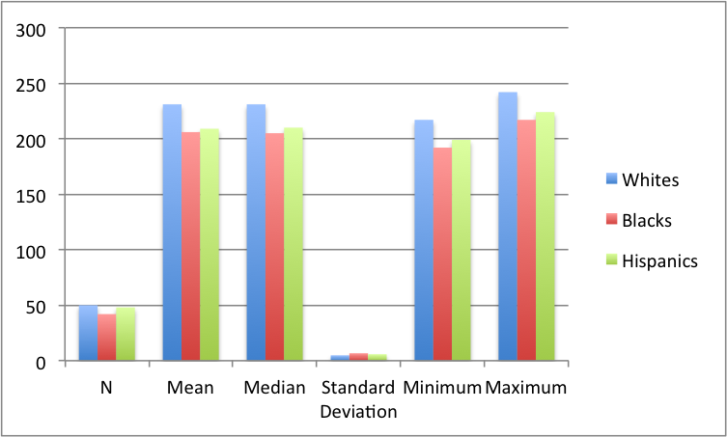

**Table 3: Clustered Column on Average Scale Score by Ethnicity**

In the clustered column above in Table 3, you can get a better look at the overall average-scale scores. White scores were ranked highest at amongst Maximum, Minimum, Median and Mean scores while Hispanic were at close behind followed by Black-average scale scores. Interesting to note that the difference for all 3 average-scale scores there Maximum and Minimum numbers was 25.

**Inferential statistics**

An Independent T-Test is used to analyze whether the hypothesis is valid or not. A t-test is often used to see if there’s a difference between one or more variables between two or more groups.

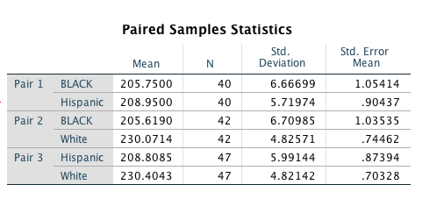

**Table 4: Paired Sample Statistics Chart on Average Scale Score by Ethnicity**

When plugging the data into SPSS, the Independent T-Test was broken down into three pairs of black + hispanic, black + white and hispanic + white due to the fact that there were a few states that didn’t have scores for all ethnicities which resulted in calculations for the mean standard deviation and standard error mean for those states where both pairs had actual data. This led to a difference in **(N)** for the 3 different pairs.

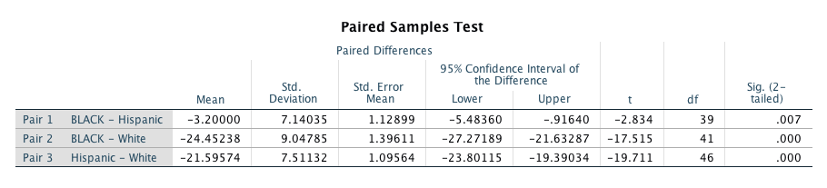

**Table 5: Paired Samples Test Score on Average Scale Score by Ethnicity**

Furthermore, when coming up with differences here you can see that when looking for the T-score (located in the T-column above) that white-average scale scores are significantly higher for pair 2 and pair 3. You can see a large difference in pair 1 (Black-Hispanic) vs. pair 2 and pair 3 when it comes to the mean and the T-Score.

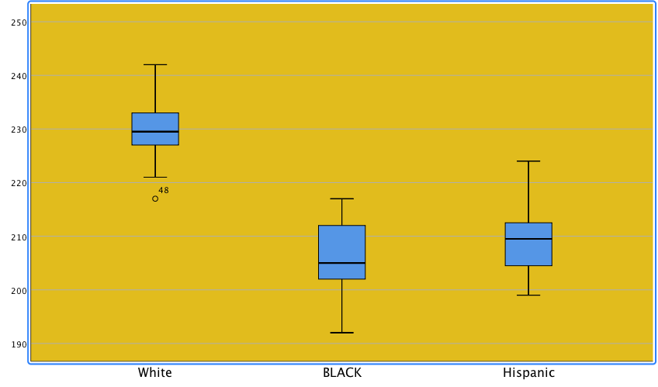

**Table 6: Box Plots on Average Scale Score by Ethnicity**

Box plots are helpful to examine any numbers that may by an error within a data set. The 5 areas that are shown in a box plot include Minimum, 1st quartile (25th percentile), Median, 3rd Quartile (75th percentile) and then maximum. The data spot that is sometimes shown in a box plot and is important for this analysis is the outlier. If an outlier is an open circle (as it shows in white-average scale scores) it should be looked at but if there is a star this indicates an extreme potential error in a data set. The **outlier** here is indicated as (**48)** which is the row the box plot was created in SPSS. This brings a conclusion that White-average scale scores may want to be looked at more closely then the others. Consistency for Whites and Blacks is higher than Hispanics. However White scores are much higher than the other two meaning if you were looking at high performance you’d want to go with the White-average scale score. You can tell from the sizes of the boxes that there’s an equal distribution for white average-scale scores. This is also true because of the median being in the middle of the box.

**Conclusion**

Based on the Independent T-Test score, tables and analysis examined we would reject the Null Hypothesis. We would approve the Alternative Hypothesis which is that Hispanic students on average do not score as well as white students on the Nation’s Report Card. Further research should be conducted now that the 2017 results have been released and recommendations made to State Department of Education where Hispanic students reside to assess ways of supporting and improving their performance in reading in future Nation’s Report Cards to narrow the gap between White and Hispanic students.More uniform capturing of student ethnicity data on the state level is an area that should be considered as an improvement for NAEP.

**References**

*R. (2015, September 25). Creating and Interpreting Boxplots in SPSS. Retrieved from https://www.youtube.com/watch?v=M58Ww51xhso*

*NAEP Nations Report Card - National Assessment of Educational Progress - NAEP. (n.d.). Retrieved from* [*http://nces.ed.gov/nationsreportcard/*](http://nces.ed.gov/nationsreportcard/)accessed April/May 2018

NAEP - 2015 Mathematics & Reading Assessments. (n.d.). Retrieved May 1, 2018 from

[ttps://www.nationsreportcard.gov/reading_math_2015/#mathematics/state?grade=4](https://www.nationsreportcard.gov/reading_math_2015/#mathematics/state?grade=4)

accessed April/ May 2018.

*SALKIND, N. J. (2017). Statistics for people who think they hate statistics statlab online 2.0. SAGE PUBLICATIONS.*

Schraer,M., " “Boxplots and Skew” Online video clip, YouTube, May 6,2018.https://www.youtube.com/watch?v=L68iieC2Vgc

*U.S. Census Bureau QuickFacts: UNITED STATES. (n.d.). Retrieved from https://www.census.gov/quickfacts/fact/table/US/PST045217*

**Appendix I**

**Exhibit I - NAEP Data Set used for Statistical Analysis**

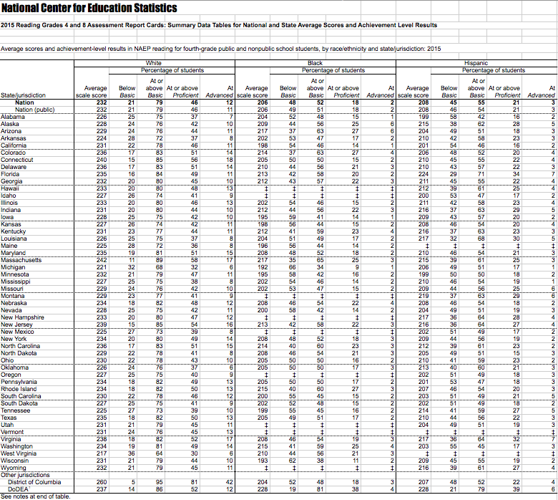

**Appendix II**

**Exhibit II - US Census Information by Race and Ethnicity July 1, 2017**

|  |  |
| --- | --- |
| **Population** |  |
| **Population estimates, July 1, 2017, (V2017)** | **325,719,178** |
| **Population estimates, July 1, 2016, (V2016)** | **323,127,513** |
| **Population estimates base, April 1, 2010, (V2017)** | **308,758,105** |
| **Population estimates base, April 1, 2010, (V2016)** | **308,758,105** |
| **Population, percent change - April 1, 2010 (estimates base) to July 1, 2017, (V2017)** | **5.5%** |
| **Population, percent change - April 1, 2010 (estimates base) to July 1, 2016, (V2016)** | **4.7%** |
| **Population, Census, April 1, 2010** | **308,745,538** |
| **Age and Sex** |  |
| **Persons under 5 years, percent** | **6.2%** |
| **Persons under 18 years, percent** | **22.8%** |
| **Persons 65 years and over, percent** | **15.2%** |
| **Female persons, percent** | **50.8%** |
| **Race and Hispanic Origin** |  |
| **White alone, percent**[**(a)**](https://www.census.gov/quickfacts/fact/table/US/PST045217#qf-headnote-a) | **76.9%** |
| **Black or African American alone, percent**[**(a)**](https://www.census.gov/quickfacts/fact/table/US/PST045217#qf-headnote-a) | **13.3%** |
| **American Indian and Alaska Native alone, percent**[**(a)**](https://www.census.gov/quickfacts/fact/table/US/PST045217#qf-headnote-a) | **1.3%** |
| **Asian alone, percent**[**(a)**](https://www.census.gov/quickfacts/fact/table/US/PST045217#qf-headnote-a) | **5.7%** |
| **Native Hawaiian and Other Pacific Islander alone, percent**[**(a)**](https://www.census.gov/quickfacts/fact/table/US/PST045217#qf-headnote-a) | **0.2%** |
| **Two or More Races, percent** | **2.6%** |
| **Hispanic or Latino, percent**[**(b)**](https://www.census.gov/quickfacts/fact/table/US/PST045217#qf-headnote-b) | **17.8%** |
| **White alone, not Hispanic or Latino, percent** | **61.3%** |

**(Source: U.S. Census Quick Facts: www.census.gov/quickfacts)**