#### TO: Superintendent Kyle Miller and Members of the Board of Education

FROM: Kerry Magro, Educational Technology Instructor, Senior Class Advisor

#### DATE: July 17, 2016

#### SUBJECT: A Proposal for a Senior Class Holiday Extravaganza Community Service Initiative

The incoming Senior Class has met and proposed a Holiday Extravaganza in fulfillment of their community service requirement.

This proposal discusses all the activities involved and resources required to carry out the event. The Holiday Extravaganza, which will consist of creating a Holiday Pop-Up Art Store at the Indian Art Museum where Student Art will be displayed and sold with all proceeds benefiting the North Valley Food Bank. The event will take place two weekends in December, December 10,11, and 17, 18 from 10 am to 4 pm and will be staffed by student and school volunteers.

North Valley Food Bank is an ideal charity given the high incidence of unemployment, hunger, and poverty in our region.

The proposal requires approval by the administration and School Board of the concept and commitment to the resources financial and time within the school and afterschool day to create the art, plan the event and implement a successful experience.

We hope the Board will present a check for the money raised at the December Board meeting to North Valley Food Bank in time to make an impact in the lives of needy people in our North Valley community for Christmas.

To meet the timeline, I am asking approval at the August Board of Education meeting.

If you require additional information, please contact me at [Kmagro@nvrhs.org](mailto:Kmagro@nvrhs.org)

#### 887436d4-6e79-44c7-aa98-38ed5ab6f6e4

#### A Senior Class Initiative

#### Holiday Extravaganza Proposal

#### A Pop-Up Art Store

#### Benefiting

#### North Valley Food Bank

##### July 28, 2016

**Presented to:**

**Superintendent Kyle Miller and Members of Board Of Education**

**Kerry Magro**

**Senior Class Advisor**

Email: kmagro@nvrhs.org

**Section I – Executive Summary**

This proposal discusses all activities and resources of the senior class in fulfillment of their community service requirement. They propose to carry out a Holiday Extravaganza, which will consist of a Holiday Pop-Up Art Store at the Indian Art Museum. Student Art will be displayed and sold with all proceeds benefiting the North Valley Food Bank. The event will take place two weekends on December 10, 11, 17, and 18, from 10 am to 4 pm and will be staffed by student and school volunteers.

# Section II – Mission, Goals, and Idea

The Senior Class will create a Holiday Extravaganza for our school community to benefit the North Valley Food Bank. In doing so, we will come together as a class, a school, and the North Valley Community to capture the true spirit of the holidays which is giving.

**The Need for the Project & Origin of the Idea**

Studies show that poverty can be alleviated based on the charitable donations. In 2015 the United Nations “ Millennium Development Goals Report” stated only 9.6% of the world is currently living in extreme poverty vs. 44.3% in 1981.[1] This statistic shows that our society has indeed been making a difference, but we can't stop there. We have to continue to find venues that can make a difference, and this is where our students come in.

Students will have experience-based learning in the creation and sale of art, setting up an event, finance, economics, marketing and digital media strategy while planning and hosting this experience.

Pop-Stores are becoming popular in the workplace. Usually hosted in an office lobby everything to be sold is brought on site for a day or two and then shut down and removed.

## Goals

To support our community during the holiday season by producing artwork to be sold. To raise $20,000.00 to strengthen our school community, and learn to execute a function successfully. To make a difference in lives of our community members.

# Section III – Background Information

**Project Background**

Northern Valley Regional High School consists of 950 students from the Kansas area. They have an award winning art program. Students have won state and national awards. Each school year the students must do 10 hours of community service. They have opportunities both in and outside the schools to give back and fulfill this requirement. For the past five years, each class advisor during the academic year for the freshman, sophomore, junior and senior classes has offered one service opportunity for their students.

Kerry Magro, who has a background in business from Seton Hall University before going back to NJCU to receive his doctorate in Educational Technology Leadership to become a teacher, has firsthand experience in the benefits of helping nonprofits thrive. Based on CharityNavigator.org's Digital Giving Index it indicates that in 2014 out of the over 45,000 nonprofits 31% of annual giving occurred in the month of December.[2] End of the year giving allows individuals to make tax-deductible donations to organizations before the end of the year.

The senior class thought of combining a service opportunity in the non-profit world during the holiday time is a win-win idea for all parties involved.

To execute this endeavor, we will partner with the North Valley Food Bank and the Indian Art Museum located three miles from the high school campus. Last year the Senior Class volunteered and participated in Santa’s Elf Factory at the Museum for two weekends in December. This event gave Developmentally Disabled children anopportunity tomeet Santa and his elves. Management of the Museum invited NVRHS back this year. They have agreed to host our students as a Pop-Up Art Store (see conceptbelow) with ten percent of all Museum admission ticket proceeds going to the student initiative, and all proceeds from art sales.

Northern Valley Food Bank has been operating since 1988; its mission is to support the community by providing food and shelter by providing meals, and groceries to all who enter its doors.

The Indian Art Museum has been operating since 1943 and has an annual Holiday Festival the first two weekends in December. Hours are 10-4 Saturday and Sunday. During this time they offer their lobby spaces to community groups. The Pop-Up Art Store can operate within this area if the School Board enters into a License agreement with them.

# Section IV – Organizational Matters

North Regional Valley High School, Northern Valley Food Bank, and the Indian Art Museum will be the three top organizations involved and will either sponsor or benefit from the experience. (Organization Chart Attached)

## Management Team

The key team will be Kerry Magro, Senior Class Advisor, Nancy Kist, NVHSS Art Director, Jim Chaffe, NV Food Bank, and Audrey Winkler, Director of Development, Indian Art Museum. Senior Class Managers will be recruited this summer and in the first few weeks of school and broken into subcommittees to cover all identified tasks required. A committee will be formed of managers that will report to the Senior Class Advisor.

Once the concept is approved students can be recruitment in four areas: The Art Committee, The Pop-Up Store Committee, The Community Outreach and The Publicity Committee. These committees will need ongoing support from the School District in legal, accounting, and managerial services including ordering supplies, entering into the license agreement with the Museum, getting permission slips signed to attend the event, arranging for photo releases, transportation, security, and insurance. (Organization Chart Attached)

**Section V - Timeline and Activities (Attached) Appendix II**

**Section VI – Marketing Plan**

**Products/Service/Pricing**

# Original Art created by NVRHS students will be provided at no cost. A committee aided by our Art Director Nancy Kist will be formed to set prices. The Marketing Committee will oversee the Advertising consisting of newspaper, radio, TV, Internet, and flyers. The Public Relations department of the Indian Art Museum will assist with a Press Release and add the event to their web page, and North Valley Food Bank will also promote on their web page. Students will oversee all aspects of social media.

# Section VI – Financial Plan

A Budget request of $7,500 has been prepared for consideration at August Board meeting. This estimate includes the cost of supplies, insurance, equipment, transporting of students, meals for students, advertising and promotional, equipment and inventory costs. Anticipated sources of funding for the event: Senior Class School Initiative Budget, Extracurricular Budget, School Funds, and Contributions. Detailed requests with the backup will be provided monthly to the Board.

**References**

Millennium Developmental Goals (n.d.) Retrieved July 22, 2016, from http://www.undp.org/content/undp/en/home/sdgoverview/mdg_goals.html

# CharityNavigator.org's Digital Giving Index, <http://www.networkforgood.com/digitalgivingindex/> accessed July 17, 2016

# Appendix and Attachments

Timeline of Activities Appendix I

Organizational Chart Appendix II

Holiday Flyer Appendix III

**Appendix I –Timeline of Activities**

|  |  |  |  |  |
| --- | --- | --- | --- | --- |
| Task Name | Duration | Start | Finish | Resource name |
| Send an email out to students, staff & parents about volunteering for the day of the event. | 4 hours | 7/14/16 | 7/14/16 | Kerry Magro |
| Figure out security for the event | 4 hours | 7/15/16 | 7/15/16 | Kerry Magro |
| Send note out to senior students asking them to start thinking about what their artwork project will be | 8 days | 7/21/16 | 7/31/16 | Kerry Magro, Art Coordinator |
| Finalize security for the event | 1 day | 7/31/16 | 7/31/16 | Kerry Magro |
| Receive approval of Board of Education | 1 day | 8/18/16 | 8/18/16 | Kerry Magro |
| First day of school. Send out extracurricular waivers to all senior’s parents for going to the event off site, and photo releases | 6 days | 9/9/16 | 9/16/16 | Kerry Magro |
| Send out press release to local television stations/papers asking for media coverage | 1 day | 9/7/16 | 9/7/16 | Kerry Magro |
| Form subcommittees in the senior class to promote the event | 1 day | 9/19/16 | 9/19/16 | Kerry Magro |
| Marketing | 79 days | 9/5/16 | 12/17/16 | Publicity Committee |
| Distribute the flyers to classmates, hanging posters in the hallways | 5 days | 9/5/16 | 9/9/16 | Volunteers |
| Create marketing materials including print and social media. | 79 days | 9/5/16 | 12/17/16 | Web Team |
| Face book event, fliers, podcasts, video YouTube & email blast | 79 days | 9/5/16 | 12/17/16 | Web Team |
| Eventbrite page to encourage people to come out to the event | 79 days | 9/5/16 | 12/17/16 | Web Team |
| Email campaign, media contacts & press release | 79 days | 9/5/16 | 12/17/16 | Web Team |
| Designate one of the students to keep a record of all the artwork | 1 day | 9/20/16 | 9/20/16 | Art Coordinator |
| Parent/Teacher Conference – discuss importance of the event, ask for donations from parents & if any of them would like to volunteer for the event | 1 day | 10/3/16 | 10/3/16 | Kerry Magro |
| Rough draft of students’ artwork due | 0.5 days | 11/5/16 | 11/5/16 | Kerry Magro Art Coordinator |
| Artwork final draft due; send out press release on event | 0.5 days | 11/22/16 | 11/22/16 | Kerry Magro, Art Coordinator |
| Finalize how much each art piece by the students is worth for tagging | 5 days | 11/23/16 | 11/29/16 | Budget Committee |
| Class trip for students to see the venue space | 0.5 days | 11/30/16 | 11/30/16 | Kerry Magro, Art Coordinator, Store Committee |
| Decorate site in holiday theme | 1 day | 12/5/16 | 12/5/16 | Art Coordinator, Store Committee |
| Move artwork to site | 1 day | 12/5/16 | 12/5/16 | Art Coordinator, Store Committee |
| Set up for the actual event | 1 day | 12/5/16 | 12/5/16 | Art Coordinator |
| Have art coordinator share announcement on the intercom announcing the event that weekend | 2 days | 12/5/16 | 12/5/16 | Kerry Magro |
| Dry run for the event | 1 day | 12/6/16 | 12/6/17 | Store Committee |
| Event takes place  Event takes place | 2 days  2 days | 12/9/16  12/16/16 | 12/10/16  12/17/16 | Store Committee |
| Breakdown of Pop-Up Store | 1 day | 12/18/16 | 12/18/16 | Store Committee |
| Monies collected, deposited in School Event Account | 1 day | 12/18/16 | 12/18/16 | Finance Team |
| Check is presented to Northern Valley Food Bank at December Board of Education Meeting | 0.5 days | 12/20/16 | 12/20/16 | Kerry Magro, NVRHS Art Director |

**Appendix II – Organizational Chart for Activities**

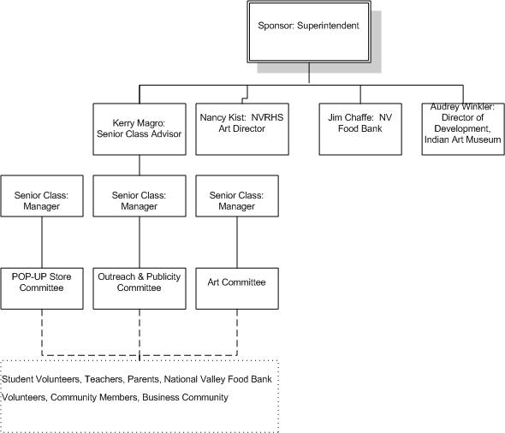

**Appendix III – Holiday Flyer**

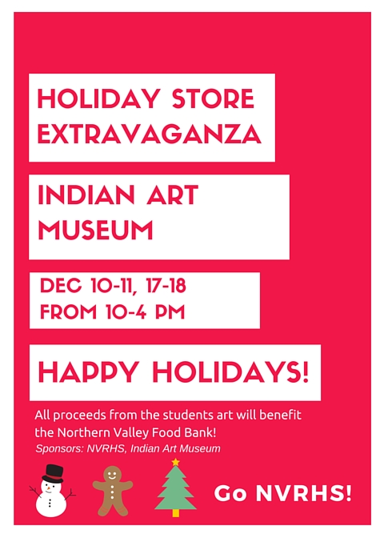

1. Millennium Developmental Goals (n.d.) Retrieved July 22, 2016, from http://www.undp.org/content/undp/en/home/sdgoverview/mdg_goals.html
2. <http://www.networkforgood.com/digitalgivingindex/> accessed July 17, 2016