Jobs in K-12, Corporate, and Higher Education

9071 EDTC 808 Summer Institute in ETL II

New Jersey City University

Dr. Christopher Carnahan

Summer 2017

Kerry Magro

**K-12 Education Technology Jobs**

**Director for Research and Innovative Technology:** The Director of Technology position will be a part of the Superintendent’s Leadership Team for that district. The director will lead the school districts’ technology initiatives along with research of district programs. Requirements for this position include an administrator certificate, 10 years of educational experience and 3 years of work in an administrative/supervisory position. Further requirements include strong communication and presentation skills. Read the job posting [here](http://www.jcboe.org/boe2015/index.php?option=com_content&view=article&id=184&Itemid=1227).

**Supervisor of Special Education Technology:** The Supervisor of Special Education Technology will oversee the supports and needs of the Special Education team. Requirements for this position include 4 years of supervisory experience and 7 years of experience in a technology-related field. The supervisor must be able to coordinate with the District Level and Administration and Principals on Special Education.Read the job posting [here](https://www.startwire.com/express_apply_jobs/MjEyNF8xYTM4YTk0YmNiMThiYTNlMjc3OGViNTdmMTNkMjdiY19sdXVhX2k=?source=glassdoor_l2).

**Director of Instructional Technology and Curriculum:** The Director will be responsible for develop the overall theme for the school system’s Instructional Technology. The Director will be required to be a liaison to teachers in the use of technology in the classroom. Requirements for this position include at least 3 years of teaching experience in a K-12 setting. The applicant must also demonstrate a knowledge of emerging trends in instructional technology. Read the job posting [here](https://www.schoolspring.com/job.cfm?jid=2828534).

**Corporate Sector Jobs**

**Inclusion Facilitator:** The responsibility of facilitators will be to develop and provide professional learning opportunities for faculty in K-12 schools to help educate and provide strategies on how to help assist students with disabilities. These opportunities will include but are not limited to workshops and small group sessions. Applicants must have experience in inclusive education. The position requires a graduate degree in education and previous experience working in or collaborating with a school system. Read the job posting [here](https://www.higheredjobs.com/admin/details.cfm?JobCode=176534816&Title=Inclusion%20Facilitator%20%28MTSS%3B%20K-12%29%20Immediate%20Hire).

**Learning and Development Consultant**: The consultant will be responsible for serving as a mentor to employees through professional training and development programs. The consultant will be required to create plans and assess progress amongst the employees. The applicant for this position should have previous leadership and/or mentoring experience. A Human Resource, Psychology degree or related field is also required for this position. Read the job posting [here](https://www.indeed.com/cmp/Royal-Caribbean-Cruises-Ltd./jobs/Learning-Development-Consultant-3534fad6db1da876?q=Educational+Consultant).

**Director of Educational Program:** The Director will collaborate with colleagues in the International Social Impact department. They will support program development via all international projects. The application is required to have at least 7 years of experience working in an educational-related setting. The applicant must be willing to travel as required. A doctoral degree in International Education, Development or a related field is preferred. Read the job posting here. Read the job posting [here](https://careers.jobscore.com/careers/sesameworkshop/jobs/director-educational-programs-bgBgiImoer57X-dG1ZS6tF?jpid=ccVMlYEACr57cFdUUuQWh_&name=GlassDoor&sid=69)

**Higher Education Technology Jobs**

**WebCampus Operations Manager:** The manager position is responsible for executing payroll procedures and helping with the scheduling of online courses for each academic semester. The manager will also be responsible for assisting in digital marketing tools including the school’s website and social media channels (Facebook, Twitter and Linkedin among others). The requirements for this position include an understand of all MS Office applications and a familiarity with e Learning systems. The application should also have at least 2 years of professional administrative experience along with past experience in taking online courses. Read the job posting [here](https://stevens.wd5.myworkdayjobs.com/en-US/External/job/Hoboken-NJ---Main-Campus/WebCampus-Operations-Manager_RQ20143).

**Academic Resource Center Director:** The Director is responsible for designing student support services, creating strategic planning and budgets and designing online programs. The Director is required to have significant experience in classroom and online teaching. A Master’s degree, Ph.D., or Ed.d is also a requirement. Read the job posting [here](https://www.glassdoor.com/job-listing/academic-resource-center-director-online-course-director-instructional-computing-information-t-cuny-city-university-of-new-york-JV_IC1132348_KO0,94_KE95,127.htm?jl=2488213986).

**Director of Network for Educational Renewal:** The director will be responsible for managing and organizing the internal network at the university. Responsibilities will include being the chairman for several committees and providing a vision and leadership for growth. Requirements for this position include an experience working with partnerships in the educational field. Applicants must hold a Master’s degree in education along with demonstrating previous leadership experience in the school systems. Read the job posting [here](https://careers.insidehighered.com/job/1413033/director-montclair-state-university-network-for-educational-renewal/).

**Analyzing Common Technology Jobs**

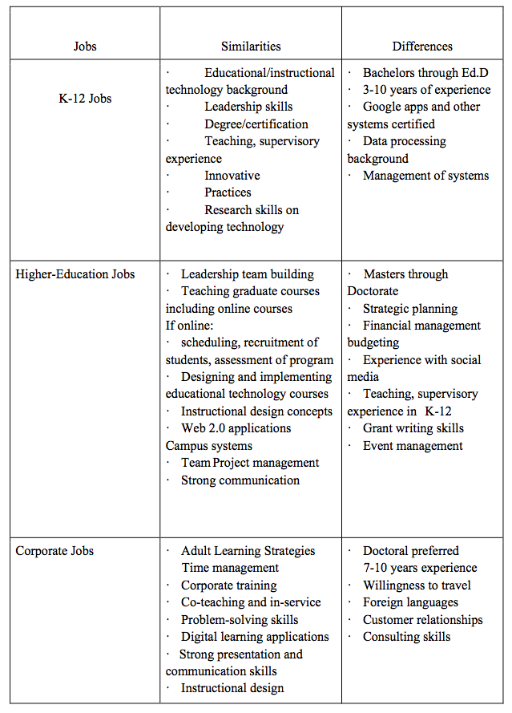

**Reflection:** **What I Would Like To Do For A Job**

Assisting and supporting student success at all levels is my goal. My ideal job I see myself having in the future is working within a college administration to implement programs for post-secondary special needs students to make them successful. I see a large component of the strategies will involve a focus on innovative educational practices and assistive technology. The role would require an education background that would be supported via a Doctor in Education in Educational Technology Leadership from New Jersey City University. Through this paper I started by researching K-12 leadership innovation positions within the school system. Then I looked into higher education positions that included disability services. Finally, I researched positions in the corporate sector as an educational consultant and for two groups I have dealt with Royal Caribbean and Sesame Street which is looking to expand internationally.

Working as a professionally certified speaker for the past seven years once of my greatest strengths is the ability to present in front of a group. This is an important part of being able to connect and adapt to students who are constantly evolving in the way they learn in the classroom. Being a team player is another strength that I have that could excel in an education setting. A needs assessment of my qualifications reveals my greatest weaknesses as of right now is lack of classroom experience. I need to formalize my my educational experiences and certifications moving forward.

This project was very helpful in helped me assess where I can start looking for job positions in the education field. From someone who comes from a business and communications background, this opened the door for me to understand how I could pinpoint and narrow down education jobs that interest me in the future and what I have to do now to begin to prepare.