EDTC 816 Advance Methods for Building Online Communities

April 15, 2018

Kerry Magro

**Educating Parents Who Have Children with Autism**

[**Online Community**](https://plus.google.com/communities/111705440740530932214)**: https://plus.google.com/communities/111705440740530932214**

**Introduction**

Having a child diagnosed with autism instantly presents challenges to their parents.

Research show families are extremely stressed and that finding ways to cope can have a significant benefit in long-term outcomes. One of the prime strategies is the empowerment of parents through education.

Increasingly, online support groups fill this role. The Autism Society of Minnesota (AUSM) 2017 conference proceedings presented by Executive Director John Weinberg (2017) reported that depression and anxiety increases in family members who have responsibility for care of their children. AUSM has a new initiative to provide online support to parents by training parents on the issues surrounding Autism, what it is, what to expect and how to help your child and yourself. It takes a community. “Autism doesn’t come with an instruction guide” Increasingly the successful outcomes for these children depends on having parents, grounded with information, who will become their biggest advocates. (Magro 2017)

**Basis and Stakeholders**

Stakeholders will include parents who have children on the autism spectrum. From working in digital media, traffic when it comes to Autism Spectrum Disorders and other developmental disabilities the largest demographic falls into females from the ages of 25-44. Microtargeting here will be essential to building this community.

**Background**

Many communities have been formed online to help educate our autism communities .and function as a Community of Practice (Wenger 1998). Vogl (1974) suggests the success of these communities rely in how well we understand shared values, membership identity, moral proscriptions, and insider understanding Paloff and Pratt (2007 (p10) suggests participants find a community where they can relay their concerns and share new information learned.

Thanks to Google Communities, this is a resource for online communities. My Google Online Community called ‘Educating Parents Who Have Children With Autism” will help parents receive impactful resources ‘ for families of newly diagnosed children with autism. (Example of what it looks like in Appendix A)

Kraut, Resnick, and Kiesler (2012) points out many online communities have difficulty establishing a concrete mission and therefore never are successful. This community has its main goal clearly stated in the title which is to help educate these parents. This is a theory that many online communities use today to build on Search Engine Optimization (SEO) and word of mouth via social media.

As mentioned in the book Building Successful Online Communities,(Paloff & Pratt 2007) persuasive messages will be included to help bring in key thinkers in the field to discuss the topic of autism. The goal of “Educating Parents Who Have Children With Autism” is to provide resources to families of newly diagnosed children with autism.

A common question that brought up the creation of the Group Monthly post challenges will be added to the online community to encourage members to post in the ‘community at least once a month. Another design of the Online Community will include a monthly ‘poll for members who don’t have time to post to stay engaged (example poll in Appendix B).

**Design Approach**

I decided to use a collective effort model as discussed in the book Encouraging Contribution to Online Communities, (Kraut& Resnick) “people will contribute more to a group if they think their contributions make a difference the group’s performance.” (p.63). As many of the community members we will be targeting our parents of children with autism who share similar stories this model seems to have an opportunity to work well. While the model is important, many parents who struggle with trying to find resources could lead to a bonds-based commitment which means members will be more likely to develop a connection with others in the community because they will be able to like and relate to their own journeys.

**Compare and Contrast**

Our newly designed site focuses on Google Groups and as mentioned in this paper a focus on helping parents with newly diagnosed children on the autism spectrum. From past experience with my own online community in a Facebook Page called ‘A Special Community’ I’ve noticed both similarities and differences. One of the main comparisons with these communities is that both of them require a login to access. Both communities ask questions of their members in the hopes of sharing knowledge to truly become a Community of Practice.

Differences are that while fan pages on Facebook like ‘A Special Community’ are open for any member to join while this Google Group is a private community which requires an invitation to join. There are advantages and disadvantages to both communities as you can see in the screenshot below.

I’ve been lucky to have a following of over 115,000 followers via A Special Community that has made the page one of the most frequently searched communities on Facebook today when it comes to developmental disabilities.

With a public community, it opens it up to a diverse engagement while a private community is more selective while at the same time looking for quality over quantity. With how many ‘bots’ now dominate online communities having a private community could pay dividends in terms of educating and engaging interested members.

The site will be designed to have the participants move from the inner ring: visitors to novices to members and eventually elder members as skilled masters (Vogl p. 90) Autism is a lifelong journey and there will be plenty of opportunities to support, educate and grow for the parents who become part of this online community.

**Conclusion**

In summary, constituting a digital habitat, we can see that this Google Community works with providing a tools view for supporting community members from the discussion board questions and interactive polls. Online communities have utilized social media, online forums, wikis and much more. As the community grows in membership, opportunities to create subgroups along with expanding the roles of members can include moderators to review posts and content creators to make sure engagement stays at a high level. All online communities mission, if they want to succeed, must have a defined purpose and with the purpose of educating parents of children with autism, there is an opportunity for this community to flourish and be successful overtime.

**References**

*Autism Society of Minnesota Conference Proceedings, April 26-29, 2017*. (n.d.).

http://www.ausm.org/

Buzzing Communities: How to Build Bigger, Better, and More Active Online Communities by Richard Millington. (2012, October 27). Retrieved April 14, 2018, from https://www.goodreads.com/book/show/16136186-buzzing-communities

Hinds, P. J., & Kiesler, S. (n.d.). Building Successful Online Communities. Retrieved April 14, 2018, from https://mitpress.mit.edu/books/building-successful-online-communities

Kraut, R. E. & Resnick, P. (Under contract). Evidence-based social design: Mining the social sciences to build successful online communities. Cambridge, MA: MIT Press.

Magro, K. F. (Ed.). (n.d.). A Special Community. Retrieved April 14, 2018, from https://www.facebook.com/ASpecialCommunity/

Paloff, R.M., & Pratt, K. (2007). *Building online learning communities,* (Second edition ed.). San Fransisco, CA: John Wiley & Sons.

Technology for Communities. (n.d.). Retrieved April 14, 2018, from <http://technologyforcommunities.com/>

Vogl, C. (2016). *The art of community: Seven principles for belonging*. Oakland, CA

Wegner, E. (1998) Communities of practice, New York, Cambridge University Press

**Appendix A: My Google Community**

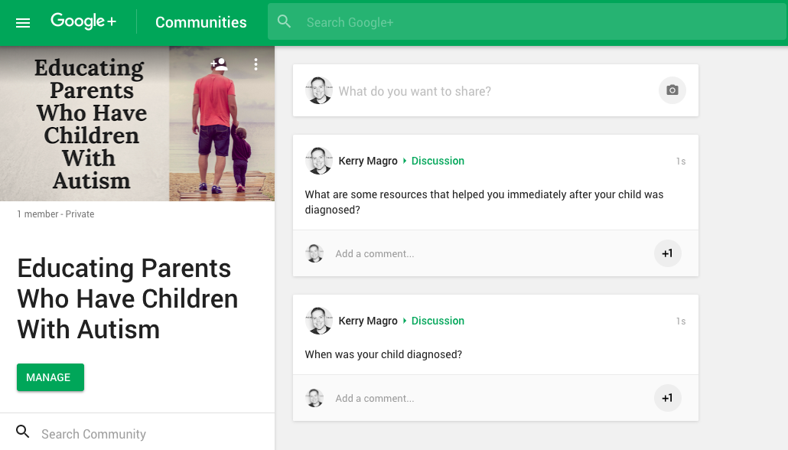

**Appendix B: Example poll**

