SECTION 1, THE STUDY--SMART HOMES AND THE AUTISM SMART HOME GRANT

The researcher who prescribes to Northouse’s Leadership Theory (2010) of servant leaders conducts this research topic in order to make societal change. Assessment 3 – Report with Primary and Secondary Data research looks at how Smart Homes with technology can impact the lives of individuals with autism. There are currently 3.1 million individuals and their families in the United States. Smart Homes have been grown in popularity over the past decade. In a study done last year by CNET.com indicates that eighty-seven percent of Americans today understand the impact that smart home technology can have although only one in four households are actually using the technology in their homes. The Center for Disease Control and Prevention’s new numbers of autism prevalence indicate that 1 in 68 children in the United States have an Autism Spectrum Disorder. To aid these individuals more and more technologies are being used to help assist them in their daily lives. One of primary challenges facing an autistic family is if an autistic family member wanders off. On July 15, 2016 the US Senate passed legislation called the Kevin and Avonte bill which would provide resources including grants for technology to prevent wandering, a situation where persons wander because of their disability and many times being non verbal they are found dead due to drowning.
This issue is so serious that the CDC, in 2014, recognized wandering as a diagnostic code for medical purposes. With that as a back drop this study will examine grant programs that have been set up to create Smart Homes using technological advances to provide security to these families. This report will examine why families with autism applied for Smart Home grants and what factors in smart home technology they feel will have an impact for autism families today. It will also examine how they feel about the devices that have question will be narrower by dealing exclusively with the autistic community using technology that would be installed for safety and deter wandering. Such research can add empirical information to the larger font of evidence.
What are Smart Homes anyway?
Smart Homes are defined as any technology that is used in the home to provide a benefit to those living in that particular residence. These types of technologies can include, lighting fixtures, air conditioning, televisions, computers, security systems, etc. If we look even deeper at Smart Homes we now see today technologies that will allow you to monitor your house with your smart phone. There are now devices that will also let you see who is at your front door when the doorbell rings via camera footage. Other security packages will let you lock all the doors in your house via a smart phone application. More built-in monitoring systems are being built every day to help provide and create new security opportunities.
Smart Homes have different purposes for different people but most of their purposes so far have been focused on security and energy efficiency. Countless millennial may have been first introduced to Smart Homes in pop culture by a Disney film that came out in the 1990’s called “Smart House” that portrayed a smart home taking over a household. Several years ago tech groups such as Microsoft started prototyping what Smart Homes may look like a decade from now to have a competitive advantage over their competition. In 2014 another Tech giant in Apple launched their iSmartHome campaign while Samsung and Google in the same year partnered to help expand their Samsung Smarthome App.
Tied to this is the second factor in our study-What is Elopement/Wandering?

“The U.S. Senate in July passed S. 2614; Kevin and Avonte's Law, legislation that would help safeguard children with autism or other developmental disabilities from wandering. According to a recent national survey, 33% of school-age children with autism had wandered away from caregivers within the last the last 12 months. The study also concluded this was not inattentiveness on the part of the parents but was due to a lack of understanding of the danger to them.
Kevin and Avonte’s Law is named in honor of two boys with autism who perished after wandering. Nine-year-old Kevin Curtis Wills wandered from home and drowned in Iowa’s Raccoon River in 2008. Fourteen year-old Avonte Oquendo left his school and drowned in New York City’s East River in 2014.
The study will be conducted using the database of a national autism organization that recently launched a grant program for autistic families to apply for grants for Smart Homes. One hundred and forty seven applications were received in the United States. The researcher will use surveys to interview subjects examining demographic characteristics, whether their family member is on the autism spectrum, the age of the individual living in the home, what if any problems the individuals have, what technology’s they have used to deal with issues in the past, what technologies they are using or plan to use in the Smart Home, the technologies and techniques applied before and after the receipt of the grant ,how much they are willing to pay for such technologies, and open ended questions on what other factors they wish to bring to the study’s attention.
Questions will be asked as to what technologies (both low tech and high tech solutions were being used before receiving the grant and what technologies are they planning to purchase with the funds and why? The why is what solutions or outcomes to they expect the technologies to address. The information collected will be analyzed and presented and the conclusions of the study will be used toward attention to the issue and support further grants for this population.
The study will employ a number of technologies. The survey instrument will be linked to Survey Monkey and can be completed on line. In addition each subject that was a recipient of a grant would be asked in they would like to participate via Sype and Instant Messenger in a follow up more in depth survey on how they feel the technology currently installed is impacting their family. A number of technology instruments will be used in analyzing and presenting the information including Microsoft Excel charts
The autistic individual faces many challenges. Two trends exist that can be examined by the results of the study. Wandering is a serious problem in the autism community. The CDC recently included it in its diagnostic code that Autism is a spectrum disorder that occurs across a person’s lifetime. This population is also severely under employed. Eighty One percent grow into adulthood and live with their aging parents. If the respondent lives in a Smart Home a follow up survey can delve deeper into the technologies will allow individuals not only live safely but assist in their day to day living.
SECTION 2, DATA COLLECTION
Primary Sources
The research will take place over a six-month period. The study will use primary and secondary sources. It will be a mixed method using qualitative and quantitative information from
a structured interview and demographic information the participants will be asked to provide using Survey Monkey. 147 families who applied for a Smart Home grant from a national autism organization will be surveyed. Data will be collected on why they applied and what technologies they were using prior to applying for the grant. If they received the grant, further follow up questions on what they are using will be asked. If they did not receive the grant, they will be asked how much they would be willing to pay for these technologies out of pocket.
Prior to beginning the survey, permission will be obtained from the NJCU Institutional Review Board. The group will be applicants for the Home award from a National Autism organization. Questions will be asked as to whether the participant currently has a Smart Home. What type of technologies do they use? What barriers are there to technology? Did they receive a grant for the smart home? How much was paid out of pocket? Are they concerned about safety in the home? Is someone autistic in the home? Is the autistic person non-verbal? Have they wandered or do they have other issues? Have you used tracking technology before? What is the gender, age or ethnicity of the child? What is the income level of the family?
The control group will be the 147 applicants for the Smart Home Grant. All will be asked to participate and receive a link to the questions on Survey Monkey One of the questions will be did you receive the Smart Home Grant? If the answer is yes you will be asked if you would participate in a face to face interview on Instant messenger. Fifteen families received grants. If they answer in the affirmative they would be interviewed for their satisfaction with the grant, and the technology. A survey instrument of up to 25 questions will be used for all persons in the survey and supplemented by a structured interview using Skype and instant messenger. An introduction, asking them to participate in the study will be offered. The introductory contact will include the parameters needed for study information confidentiality. As part of this academic research project a request will be made to NJCU for approval by the Institutional Review Board to work with human subjects so the research can be publishable in academic journals and give the study more credibility and show a higher quality of work that has been vetted by the institution.
Analysis
There will be an analysis of the data, a summary of the data and a T-test for those who received the grant and those who did not. A spreadsheet using Microsoft Excel will be used to tabulate the data from the research. The validity of the testing will then be reviewed. After the survey is completed, a review of the responses will be done to make sure there are no instances of someone just being non-responsive or answering in a way to throw off the survey. In that instance that survey will not be tabulated. Test-retest methodology and the data can be gathered through a structured interview process. A review of the applications will give insight into the pre test issues. The interview can be structured to collect demographic data as well as some numbers that can be crunched. The information will be presented using likert scales. It will compare the each one individually before and after as well as collectively before and after.
The primary source data collection instrument is Survey Monkey for all applicants for the grant, supplemented with the Instant messenger or Skype interview. Focus will be on assessing the outcomes for the families who use or will use Smart home technology. Secondary sources will be included. The main advantage of the secondary data is work has already been gathered by other researchers and is the most economical gathering source. An environmental scan the literature on Smart Homes, (2013) is included titled what we do - and don't - know about the Smart Home: An analysis of the Smart Home literature. This article discussed technology articles as being the relevant from 2003 till now growing exponentially. A review of smart homes—Present state and future challenges appeared in Computer Methods and Programs in Biomedicine, (2008).Wandering resource abound in peer reviewed article s and blogs and testimonials. Occurrence and Family Impact of Elopement in Children with Autism Spectrum Disorders” And I look down and he is gone”: Narrating autism, elopement and wandering in Los Angeles. Project Lifesaver is a group that is run across the country. Various summary reports on their experiences will be used. Testimonials from families who have used Smart Homes or smart home technologies will be used and any annual reports that have info from the various companies - like Project Lifesaver, smart tech providers, and other companies that are making and marketing products for these purposes. An example of a testimonial follows” We have had a terrific experience with our Smart Home supplier-

Blogs offer up to date information such as:

“Our technician has been very compassionate and so responsive to any concerns. We brainstormed together about Jackson’s needs and what they could offer.
It is user friendly and has been a terrific addition to our daily life. We are able to check and see if the green light is on, then Jackson has to be in the house. It tells us which door is open so if I hear – “back door”, I know that is where he went. We also have water sensors as he likes to turn water on in the baths and overflows. This prevents it from getting so much that we would have damage.”

Information from Project Lifesaver object life saver which is 1400 organizations in 48 states dedicated to bringing wandering persons home “a strategy that increases chances of coming home alive – signal emitting service on wrist register thru country Sheriffs office.
Another relevant secondary source is the applications themselves which can be analyzed for the before feelings in testing outcomes.

Analyzing the data - Outcomes
Presenting the data Test, Retest will be employed showing correlations. People who receive grant against those who did not will be compared as to their attitudes about technology. On top of that people can be compared before and after grant - even at same interview with the right questionnaire and analyze that through the test retest. Respondent’s feelings show is examined among those who got and did not get the grant. The before feelings should all be similar. Grant applications will be reviewed to verify the before/after and do a secondary analysis with that info.
Triangulation of data will be done using the secondary data to validate or support the primary data.
Presenting the data
Various methods will be used to present the data. The Survey questions will be presented using Pie Charts, Cluster and Likert Scales. Cross tabs will be used for some correlations work in presenting the analysis. Examples of data presentation is in Appendix B
Conclusion
Smart Homes and Safety of those with homes go perfect together. For the 23.1 million individuals with autism and their families it is imperative that we provide solutions to safeguard their lives and their futures. Research studies as this help document the problem, and offer technological means to solutions that are an important step in society's responding to this situation. The CDC has suggested laws the Congress has acted. The research will be presented at the Autism Society of America 2017 National Conference held annually attended by 4,000 people and to groups concerned with Autism such as Autism NJ’s conference. In addition it will be presented to the sponsors in Congress and the Senate of Kevin and Avonte’s law. State, national and autism societies will be presented with copies of the study and the report can be utilized as backdrop for further grant applications. A Call for Further Action will distribute it to for review and inclusion in further studies and grant opportunities for the Autistic Community. Servant leadership is two prong, study and action. The United States will be unsurpassed in its efforts to keep all children safe utilizing the technological advances available to us.

BIBLIOGRAPHY

IJSH International Journal of Smart Home, 9(1). (2015). doi:10.14257/ijsh.2015.9.1
American Psychological Association. (2010). Publication Manual of the American Psychological Association (6th ed.) Washington, DC: Author.
Anderson, C., Law, J. K., Daniels, A., Rice, C., Mandell, D. S., Hagopian, L., & Law, P. A. (2012). Occurrence and Family Impact of Elopement in Children with Autism Spectrum Disorders. Pediatrics, 130(5), 870-877. doi:10.1542/peds.2012-0762http://iancommunity.org/cs/ian_research_reports/ian_research_report_elopement accessed on the web August 4, 2016
Chan, M., Estève, D., Escriba, C., & Campo, E. (2008). A review of smart homes—Present state and future challenges. Computer Methods and Programs in Biomedicine, 91(1), 55-81. doi:10.1016/j.cmpb.2008.02.001
Kuiper, S., & Clippiner, D. (2013). Contemporary Business Reports (5th ed.) Cincinnati, OH: South-Western College Publishing.
Solaimani, S., Keijzer-Broers, W., & Bouwman, H. (2013). What we do - and don't - know about the Smart Home: An analysis of the Smart Home literature. Indoor and Built Environment, 24(3), 370-383. doi: 10.1177/1420326x13516350
Solomon, O., & Lawlor, M. C. (2013). “And I look down and he is gone”: Narrating autism, elopement and wandering in Los Angeles. Social Science &amp; Medicine, 94, 106-114. doi:10.1016/j.socscimed.2013.06.034

APPENDIX A. Data Collection Instruments
The Survey
https://www.surveymonkey.com/r/Preview/?sm=xauRXxthHtmSGBRSh_2FBqGIpKa4rCYHArbQ9pY_2FVrvUXAV7vWHSl09rkO4XCvb3v1

APPENDIX B. Presentation of Data
Pie Charts

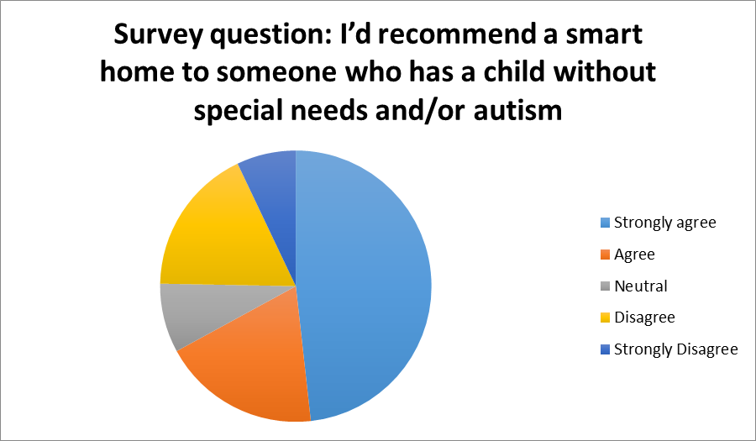

Demographics – Pie Chart

Clustered Column Chart
Survey question: What are they willing to pay for technology in a smart home?

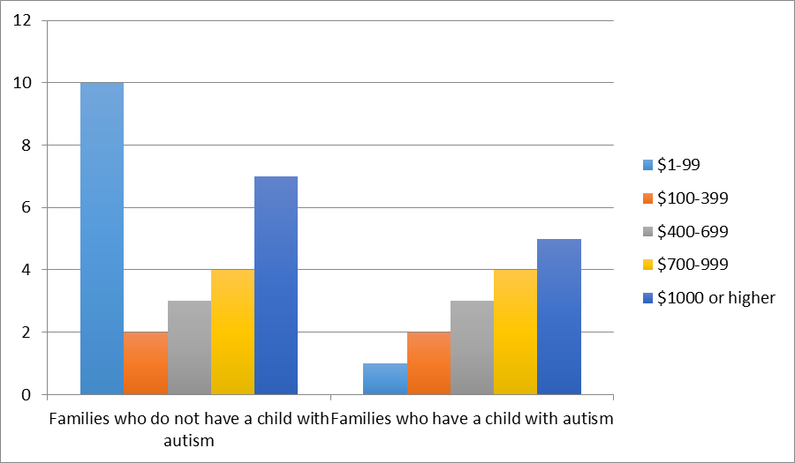

Likert Chart Excel for questions of degree
I’d recommend a smart home to (15 people surveyed) | Strongly agree | Agree | Neutral | Disagree | Strongly disagree | No opinion
Someone who has a child with autism | 6 | 3 | 1 | 2 | 2 | 1
Outcomes will be presented as to what they expect the technologies to address.

Correlation in Excel for Survey Question (description from Excel below)

The correlation coefficient (a value between -1 and +1) tells you how strongly two variables are related to each other. We can use the CORREL function or the Analysis Toolpack add-in in Excel to find the correlation coefficient between two variables.
- A correlation coefficient of +1 indicates a perfect positive correlation. As variable X increases, variable Y increases. As variable X decreases, variable Y decreases.

