**How Parents Learn about Autism after a Child is Diagnosed**

**Informal Learning and Communities of Practice**

Submitted by

Kerry Magro M.A.

2076EDTC807

Implementation and Evaluation of Curriculum

New Jersey City University

**Introduction**

“Autism doesn’t come with an instruction manual but with a family that will never give up.” (Magro, 2016)

Three central words provide the framework for this paper: Informal learning, communities of practice and autism. This paper is written to examine the role of informal learning and communities of practice in providing informal learning to help autistic parents deal with their child’s diagnosis and ongoing needs across their lifespan. Parents learn advocacy and coping skills (or about autism) after a child is diagnosed through these methods.

**Informal Learning**

Coombs and Ahmed 1974 described informal education as: “the lifelong process by which every individual acquires and accumulates knowledge, skills, attitudes and insights from daily experiences and exposure to the environment – at home, at work, at play: from the example and attitude of families and friends; from travel, reading newspapers and books; or by listening to the radio or viewing films or television. Generally,informal education is unorganized, unsystematic and even unintentional at times, yet accounts for the great bulk of any person’s total lifetime learning – including that of a highly ‘schooled’ person. (Coombs and Ahmed 1974: 8)”

**Communities of Practice**

Wenger (2008) describes learning as something that happens over time. We collectively learn and participate in what becomes the property of the community created over time and sustained by the pursuit of shared enterprise as a community of practice (p44). Thousands of COP’s have been established worldwide dealing with many common interest groups. Today we will examine a niche among them - the autism community. Lave & Wenger (p98) discusses participants share understandings, concerns about what they are doing and what it means for their loved and their communities. They also discuss access to the COP, ongoing activities, and access to old timers and resources for participation. One such community is discussed below.

**Autism**

Seventy (70) million individuals worldwide carry the autism diagnosis.

Autism is defined as a social and communication disorder that today in the United States affects 1 in 68 children as reported by the Centers for Disease Control and Prevention (CDC) (2016). Christian Et al. (2012) studied the prevalence rates which are updated annually. While many families see early signs such as limited speech, repetitive behaviors and a lack of social interaction among others many parents don’t start to learn about autism until after their children’s initial diagnosis. The American Psychiatric Association (2010) share that challenges that are accompanied with an autism diagnosis can include but are not limited to medical and mental health issues, gastrointestinal disorders, seizures, sleep disturbances, attention deficit and hyperactivity disorder (ADHD), anxiety and phobias. Research has also been done on the impact on parents and family members.

Smith (2014) states the word autism was first introduced in 1908 to describe a few patients who had schizophrenic tendencies. In 1943 it would be defined by child psychiatrist Leo Kanner, M.D. in a paper he published where he described characteristics of ‘early infantile autism’ as ‘a powerful desire for aloneness and ‘an obsessive insistence on persistent sameness.’ As the definition of autism evolved over the years,,it would fall into five subcategories until 2013 when the DSM-5 booklet came out combining all the subcategories into one umbrella diagnosis called an Autism Spectrum Disorder (ASD). Although there is no medical detection or cure for autism today in 2004, a study published in The Lancet (Smeeth et al. 2004) suggested that the measles-mumps-rubella (MMR) vaccine caused autism. This discussion brought autism to the spotlight with vaccinations receiving pushback from many parents while experts said that there was no scientific research to back the study. Fear of giving child autism through shots drove that discussion. Parents whose children have been diagnosed are the subject of this paper.

**An Invitation to Join the Group**

An invitation to be a member whether as a newcomer or apprentice begins with the following scenario. The Journey begins with these words “Your child has autism” and marks one of the most crucial times in a family’s life. The start of a lifelong journey with an autism diagnosis brings an amount of uncertainty about what’s in the store for the future for that family. Finding that child high quality care, and practical support is difficult (Valentine Et al. 2010)

Today with the advances in research of cognitive disabilities we have more opportunities to provide early intervention services to help these children progress and to have parents accept and cope with their child's diagnoses.

Clarks dissertation on a Parent Consultation Group for Parents of Children with ASD ( 2011) lays out the issues citing De Grace (2004) that families find dealing with their children are non-stop (p54 )and that the roles and routines are programmed around the needs of the child 24/7 creating occupational injustice and highest level of stress . De Grace (2004) citing Brookman-Frazee (2004) found parents relayed having a reduction in stress, positive effect and time for leisure activities by participating in educational programs for parents. Mahoney (1999) mentions parent and family empowerment as a goal for ASD families.

To help a parent learn about autism though is a completely different story altogether. In a book titled *Empowering Parents of Children with Autism Spectrum Disorders,* Whitehead (Chapter3) focuses on the role of the Internet in creating an effective Communities of Practice. Through participation in this COP parents deal with their common concerns through interaction and problem solving, Whitehead created The Autism Ladder website as a Community of Practice. Whitehead used action-based research to survey the needs of parents for information and support and created a multi-platform support forum which participants engage in worldwide. He provides an extensive review of the research in this field and it’s progression from early emails to more discussion and chat rooms with the advance of social media. He states Communities of Practice provide postive learning communities for parents of autitic children. Wenger (2002) three characterisitcs, domaincommunity and practice are present. Their passion to help their children. Cambridge cites four purposes: developing relationships, engaging in learning, carrying out tasks and creating new knowledge. The COP provides structure and support, explores relevants topics, an opportunity to gain emotional support and to construct new knowledge to help other parents.

In his support group goals we are given a screenshot of what some parents process is of learning of autism through a ‘Cycle of Learning’ (Whitehead) which you can see in Appendix A of this report. The basis is focused on looking at the child’s future focused on 1. Assessing their diagnosis 2. Setting short and long-term goals for the child. 3. Implementing a strategy based on where that child is currently in their development and then 4. Evaluating the success of that child based on the progress. Insert the research from 207, 208 209

In addition to these COP’s Autism Speaks, the world’s leading autism science and advocacy organization came out with a tool kit to assist families of young children in getting the critical information they need in the first 100 days after an autism diagnosis in their “100 Day Kit For Newly Diagnosed Families of Young Children.” This toolkit that was first released in 2008 has been downloaded over 850,000 times from families across the world to learn more about autism after their child’s initial diagnosis. This is one of the leading resources today that helps parents learn about autism after a child is diagnosed.

Other resources have been developed via organizations such as the Autism Research Institute, Autism Society of America, Autism Wandering Awareness Alerts Response and Education Collaboration, Center for Autism & Related Disorders, Interactive Autism Network, Ohio Center for Autism and Low Incidence and Organization for Autism Research to help parents. Along with helping parents these organization’s websites have a wealth of resources capable of education parents on autism from when a child is diagnosed to when a child reaches adulthood on the spectrum.

In addition to national organizational resources, there are countless support groups where families can share their experiences of having a loved one on the spectrum. Many of these support groups are separated into two categories of face-to-face local support groups and online support groups. Face-to-face support groups are often comprised of local autism organization’s special events while online support groups can include Face book groups, SLACK groups and other types of online forums (discussion boards). One of the leading online resources is a Face book page called “Autism Discussion Page” which has over 140,000 followers. The page was started by educator Bill Nason to ‘discuss tools that help children on the spectrum feel safe, accepted and competent.’ Often parents submit questions where Nason then posts the questions online for any follower to chime in on to educate.

Another COP is conferences. The Autism Society holds an annual conference, states hold conferences and conferences are held worldwide all with the intent to educate parents on how to deal with autism. The Community of Practice and informal learning takes place at Conferences on Autism. Local Special Education Parents Advocacy Committees (SEPAC) groups are established within school district's. In New jersey Autism NJ holds an annual conference. Key autism advocates such as Dr. Temple Grandhin and Dr. Stephen Shore keynote at these meetings and offer insight and hope to these Communities of Practice.

# Others have looked at literature for valuable perspectives to understanding autism. Books including educator Ellen Notbohm’s “Ten Things Every Child with Autism Wishes You Knew” provide insight from someone who works specifically with children with autism. Readings have also featured self-advocates on the autism spectrum such as Dr. Temple Grandin, who wrote “The Way I See It” which focuses on her early successes and challenges as a child. Lawson’s The Passionate Mind, How People with Autism Learn provides a primer on the learning style of autistic individuals with her theory of single attention and associated cognition reiterating “we must teach how they learn.”

Today there are thousands of paperback books available on websites such as Amazon on the topic of autism.

Advancements in technology have been able to help parents learn more about autism along with enhancing the lives of those on the spectrum. These types of technology have been through computer software, iPads and other assistive technology. Clarkson (2014) a faculty member at the University Of Ontario Institute Of Technology recently published her research on how an iOS transportation app has helped with situated learning for those with high-function autism during their young adult years to help them navigate public transportation.

Others have found that their guidance counselor, diagnostician, and schools as the best resources to understand autism after a diagnosis.

More and more parents are also looking into virtual reality to help their children with autism. A study done in 2014 looks at how virtual-reality training programs can help with social skills and brain activity for people with autism. The study focused on eight young adults on the autism spectrum who were recruited by the Center for Brain Health at The University of Texas at Dallas. They assessed that different roleplaying scenarios via a new method called Virtual Reality Social Skills Intervention had benefited them when it came to better reasoning in social scenarios.

It’s important to remember that some children with autism fall through the cracks and don’t receive a diagnosis of autism until they are teenagers or adults. Autism Speaks came up with a toolkit called “Is It Autism and If So, What’s Next? A Guide for Adults” on what you need to know about getting a diagnosis of autism as an adult. Because of this, it’s important for parents to remember that autism is a lifelong disorder and the importance of things such as self-determination for those with autism as you can see in the Appendix C.

Ongoing research on the impact of online communities has emerged. Fleischman (2005) used grounded theory to examine 33 self-published websites by parents. In her research she cites Catford and Ray (1991) who describe the development of a hero. Following a period of readjustment prepared an action plan saw their children in a positive light and was ready for helping (recreation) other parents. The study of web based sites 33 sites used grounded theory examine the hero showed parents as they move from newcomers, to old timers who can create bonds among other parents and move from isolation to empowerment. Eden has compiled the ten top autism web sites recommended by parents.

We have discussed why people initially join a Community of Practice. Initially it is for support and the resources to help their children. As their children grow and their time in the Community of Practice extends they hope to gain strategies to have their children cope across a lifespan. By now they are seeking from their informal learning and their Communities of Practice successful positive outcomes. This occurs with the movement of participants from apprentices to old timers capable of reproduction and support for newcomers across the life cycle of community of practice. Engagement continues online, at meet ups and at conferences. Participation in support sites on the webs continues and the particpants are exposed to the use of virtual reality and other apps that can assist there loved ones. Parents come out of need when their child is diagnosed but they remain in the online community because of the support and Outcomes that they plan for their children. They approach the Cycle of Learning with the Future Vision as their child’s best advocate and become empowered through the Community of Practice. The day they were invited on this journey there was no instruction manual but today they have mastered all of the resources in the autism community of which they are a vital part.

**Conclusion**

The personal journey has led us to why the need for parents to learn about a child’s diagnosis of autism is of utmost importance. Dr. Stephen Shore, an international speaker who himself is on the autism spectrum says, “If you’ve met one individual with autism, you’ve met one individual with autism.” I believe this quote helps us understand not only the need for research efforts but also for each parent to understand that to learn more about autism at its core comes down to establishing a rapport with their child and meeting them where they are in their development. With the support of these parents they will hopefully be able to see their children progress. This is one of the biggest goals a parent, regardless of autism or not has for their child.

Appendix A: Mr. Todd’s Whitehead ‘Cycle of Learning’ for Autism Parents

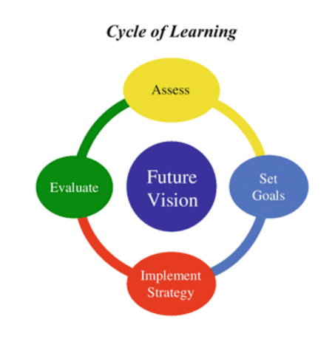

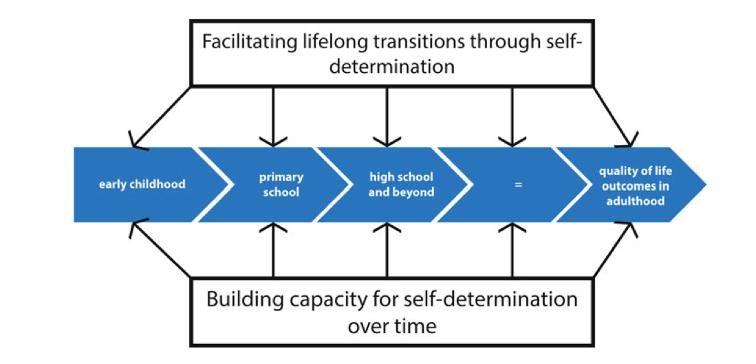

Appendix B- Sample Support Groups/Communities of Practice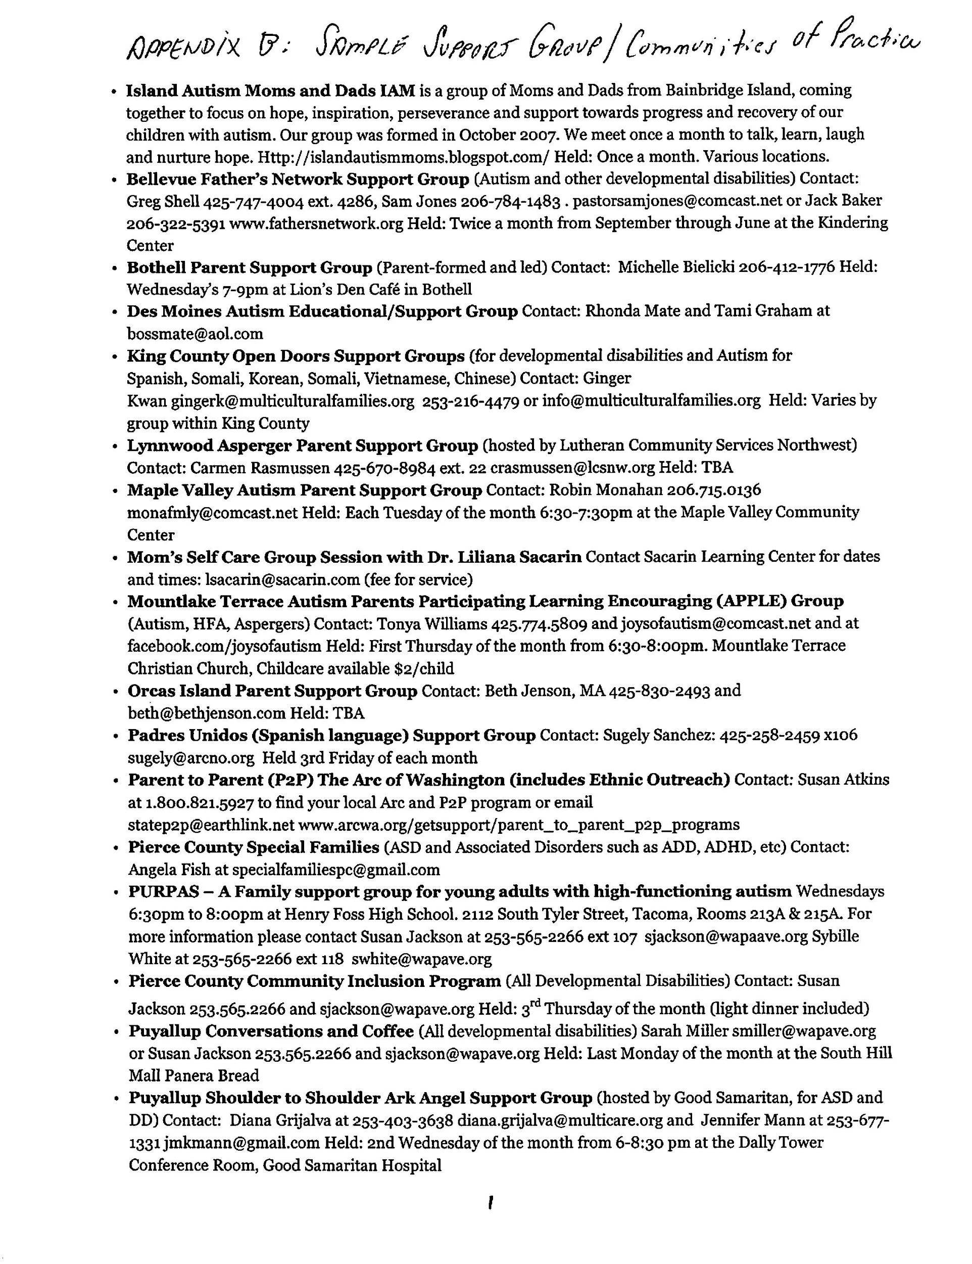

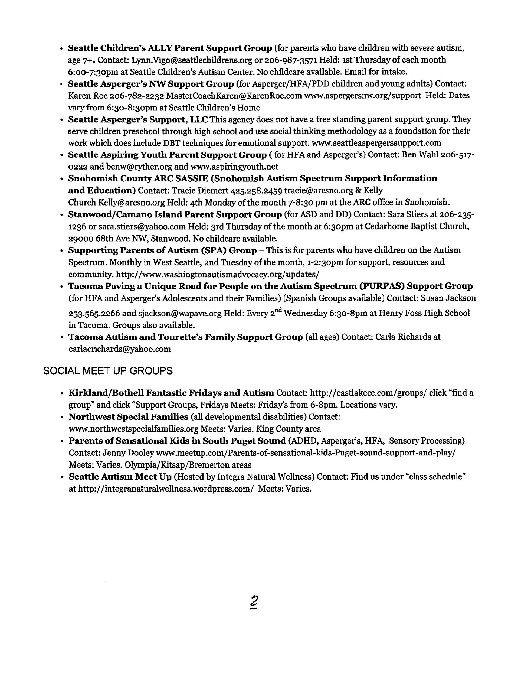

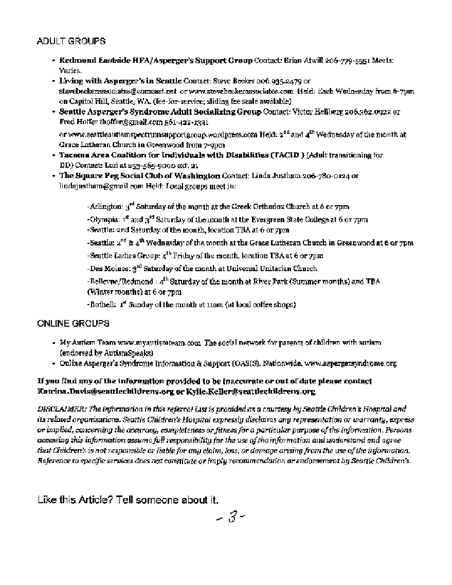

Appendix C

Page in the toolkit “Is It Autism and If So, What’s Next? A Guide for Adults”

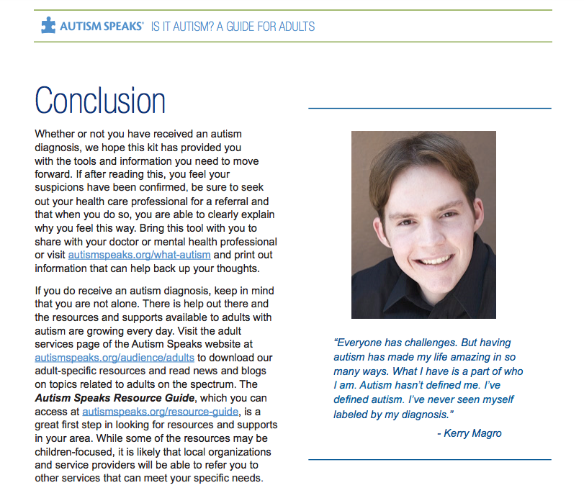

References

(n.d.). Retrieved April 14, 2017, from http://acn-sa.org/

(n.d.). Retrieved April 14, 2017, from https://www.sciencedaily.com/releases/2016/04/160406124631.htm

100 Day Kit. (n.d.). Retrieved April 16, 2017, from http://www.autismspeak.org/

Autism and Parent Support Groups. (2014, September 05). Retrieved April 16, 2017, from http://theautismblog.seattlechildrens.org/autism-and-parent-support-groups/

Autism Discussion Page. (n.d.). Retrieved April 16, 2017, from https://www.facebook.com/pg/autismdiscussionpage/about/?ref=page_internal

Barber, C. (2009). Life and learning with autistic spectrum disability Life and learning with autistic spectrum disability Wendy Lawson Jessica Kingsley 2008 DVD 154 minutes £609781843109563. *Learning Disability Practice,* *12*(1), 19-19. doi:10.7748/ldp.12.1.19.s17

Brown, N. E. (n.d.). *Social Skills Training: A Parent Education Program for Culturally Diverse Parents of Children with Autism Spectrum Disorders*.

Eden Top Ten Websites for Parents.<http://eden2.org/top-10-autism-websites-recommended-by-parents/> retrieved on the website April14, 2017.

Face book. (n.d.). Retrieved April 16, 2017, from https://www.facebook.com/Autism-Doesnt-Come-With-Instructions-948848655180724/

Informal learning: theory, practice and experience. (2014, July 09). Retrieved April 16, 2017, from http://infed.org/mobi/informal-learning-theory-practice-and-experience/

K. (n.d.). KFM Making A Difference on WordPress.com. Retrieved April 16, 2017, from https://kfmmakingadifference.org/

Lave, J., & Wenger, E. (1998). *Situated learning: legitimate peripheral participation*. Cambridge: Cambridge University Press.

Macintyre, C. (2016). *Strategies to support children with autism and other complex needs: resources for teachers, support staff and parents*. London: Routledge, is an imprint of the Taylor & Francis Group, an Informal business.

Magro, K. (2013). *Defining autism from the heart: from nonverbal to national speaker*. United States: Magro.

Nesbitt, T. S. (n.d.). *Enhancing mental health services to children with autism in rural communities: guidelines for using telehealth to extend autism outreach*. Place of publication not identified: Publisher not identified.

Understanding. (n.d.). Retrieved April 14, 2017, from https://theautismcommunity.org/

Webster, A. A., Cumming, J., & Rowland, S. (2017). *Empowering parents of children with autism spectrum disorder: critical decision-making for quality outcomes*. Singapore: Springer.

Wenger, E. (2008). *Communities of practice: learning, meaning, and identity*. Cambridge: Cambridge University Press.