Online Support Group for Parents of Children with Autism Spectrum Disorder

A MIXED METHODS DESIGN

by
Kerry Magro

Research Methods for Educational Leadership
2075 EDTC

Dr. Christopher Canaharan
Spring 2017

Abstract

Online Support Group for Parents of Children with Autism Spectrum Disorder

“Autism doesn’t come with an instruction manual but with a family that will never give up’(K)

With the growing prevalence of autism in society families are faced with many challenges leading up to and on hearing their child’s diagnosis. Studies show families are stressed and that the most appropriate coping mechanism for successful outcomes and empowerment of parents is education. Increasingly, online support groups are formed for this purpose. This Convergent parallel mixed methods research study was conducted using 25 subjects recruited from face book and took place over eight months. Subject were given quantitative pre-tests, participated in a eight week online program and given post tests to determine the impact of the training and support sessions and semi structured qualitative interviews which were analyzed for themes to support the quantitative data. The results show empowerment of participants and reduction in anxiety and stress symptoms from participation in the online support program

Table of Contents

Page
Chapter 1: Introduction 1

Chapter 2: Literature Review 8

Chapter 3: Methodology 14

References 24

Appendices A:
Steps in Research…………………………………………………….……………….29
Survey Instruments 30
Consent Forms 37

Introduction
“Autism doesn’t come with an instruction manual but with a family that will never give up’ – Kerry Magro

With the growing prevalence of autism in society families are faced with many challenges leading up to and on hearing their child’s diagnosis. Studies show families are stressed and that the most appropriate coping mechanism for successful outcomes and empowerment of parents is education. At a recent conference of the Autism Society of Minnesota (AUSM) Executive Director John Weinberg (2017) indicated that while Autism is not a mental health issue many family members responsible for care of their children suffer from anxiety and depression. Director Rowlings’ discussed the AUSM track record of providing excellent support to parent’s for many years before the internet, and their new initiative is to provide on line support to parents by training parents of the issues surrounding Autism, what it is, what to expect and how to help your child and yourself. It takes a village because as (K) indicated in an online blog “Autism doesn’t come with an instructional manual “ but increasingly the successful outcome for these children is having parents grounded with information that will become their biggest advocates.

Statement of the Problem
Seventy (70) million individuals worldwide carry the autism diagnosis. As society attempts to deal with this issue options are needed to have parents cope with their child’s diagnosis. Dehoff, B. A., Staten, L. K., Rodgers, R. C., & Denne, S. C. (2016) discussed the stress that parent’s of special needs children encounter are increased for autistic parents’. Crane, L., Chester, J. W., Goddard, L., Henry, L. A., & Hill, E. (2016) reported on the dissatisfaction that parent’s feel leading up to the diagnosis and lack of support after the diagnosis, and determined this early phase is most important.
To understand the problem we need a clear understanding of what is autism? The leading national resource is the Centers for Disease Control and Prevention (CDC) (2016) Christian Et al. (2012) defines Autism as a social and communication disorder that today in the United States affects 1 in 68 children. Prevelance rates by the CDC are updated annually . In 1988 the rates were 1 in 1000 . Boys are four times more likely to have the diagnosis but a growing number of girls are being seen. What do parents see that concerns them? Evidence of developmental delays characterize parents responses. Many children have delayed speech, lack of social interaction, and many have sensory issues. As the child ages they have repetitive behaviors, and cannot tolerate changes in routine. Most parents don’t start to learn about autism until after their children’s initial diagnosis. The whole family is impacted and the American Psychiatric Association (2010) has begun to track accompanying related medical and mental health issues, gastrointestinal disorders, seizures, sleep disturbances, attention deficit and hyperactivity disorder (ADHD), anxiety and phobias. 70 million families worldwide have autism..
Purpose of the Study
Often when a child is diagnosed parents have no exact idea on how to go about finding resources to help them support their children. Mackintosh, V., Myers, B., & Goin-kochel, R. (n.d.). examined sources of information and support used by parents’ subjects in a qualitative study following up on the work of (Pain 1999). This is where online support groups are a great resource. With 1 in 68 currently diagnosed with autism and over 3.5 million Americans who have an Autism Spectrum Disorder it’s often valuable to find a family who share a similar story to their own. The difficulties that face an ASD family are plentiful. Monetary the outlay for autism services are over $60,000 dollars a year for the average family across the life span. How can we as a society develop supports for these families? The topic of this research is Online Support Programs for Parents of Children with ASD.
Research problem
While there are a growing number of support groups, and conferences held on autism the availability of support programs is limited by location, availability and time away from the child. This study attempts to research whether an online solution which supports participants will improve the outcomes for families not only in reduction of stress and anxiety but feelings of empowerment and better coping for families? This study can be viewed as a pragmatic worldview as there is a specific problem to be dealt with but also could be looked into as a transformative world view as there is the hope that a positive outcome can lead to social support and change for this disaffected group.
The literature review chapter discusses many articles on parents attitudes and satisfaction with their childs’ diagnosis as causing stress and anxiety levels this research measures the impact of one training session developed by the Autism Society of Minnesota’s for replication online to other families if the study results show positive outcomes from the study. The audience for this study will be parents of children with ASD, special education teachers and health care providers
Purpose Statement
The theoretical basis for this study is found in Research and Design in the “Introducing a Mixed Methods Study” chapter in which (Creswell, 2010)
This mixed methods study will address the need for online parental support of children with Autism Spectrum disorders. A Convergent Mixed Method will be used. It is a type of design in which quantitative (numeric) data is collected, and qualitative (ideas) data is collected in parallel, analyzed separately and then merged. In this study three index’s Beck’s Anxiety Index, Beck’s Depression Index, and Autism Parents Stress Index will be used to test the theory (Parents who participate in online support groups) that online support will reduce the dependent variable (stress and anxiety) that the independent variable will either positively or negatively influence the dependent variable for the 25 participants online. The open-ended interview that will be conducted will explore for the same 25 participants. The reason for collecting both quantitative and qualitative data is to converge the results to support the theory and by brining the two sources of data to apply to the question a greater understanding and insight into the problem than would be obtained from one source or the other. The results of each phase (strands) are collected and then mixed for comparsion and the results are interpreted and questions answered.
Research Questions
The following research questions will be asked in this study and are designed to allow us to collect data that will support or refute the premise of the hypotheses of the study.
- Quantitative—Do parents who participate in online support groups have reduced depression and anxiety levels in dealing with their situation after participating in online support group
Hypotheses
Parent who participate in online support will cope better with their child’s diagnosis and their mental health
Independent variable – Parents who participate in online support groups
Dependent variable – less anxiety and less stress
Null hypotheses
There is no relation between stress level and on line support groups

2. Qualitative— Online support group for ASD parents

Research question
RQ #1: What are attitudes, and concerns of parents enrolled in the online support group in dealing with their situation as an ASD parent

RQ #1A:. What do you understand about the challenges of your child’s autism diagnoses?

RQ #1B:. What did you discover about autism during the online support program?

RQ #1C: How will you use the information you acquired during the online support program to help your child?

RQ #1D:. Would you recommend this program to help other parents of children with autism?

RQ #1E:. How would you change the online support program?

3. Mixed method— to what extent do parents who do or do not exhibit stress or anxiety with their child diagnosis respond to online support feel they are less stressed and anxious and look more hopeful, empowered?

Hypotheses - Education and support will make parents less anxious/stressed more hopeful about their child’s outcomes and more willing to become a mentor to other parents
Independent variable – researcher observation
Dependent variable- parents reactions to online support

Limitations
Limitations of this study include small sample size 25 participants, and the fact that the participants are self-identified. The fact that agree to be in the on line support study may mean they are not representative of a larger group of parents. Veracity of the answers from the parents is a factor.
Chapter 2: Literature Review
Introduction
The Literature Review consisted of ten articles and one book that reflected four themes: Parental Stress, Need for Support, Online Sources of Support, and Benefits or Empowerment derived from online support. Parents of children with ASD are stressed and anxious before the diagnosis, during the diagnosis process and after the diagnosis. There is a need for support in many forms especially from other parents. Online sources of support are examined which provides both emotional and informational assistance and leads to a sense of empowerment, advocacy and stress reduction.
As previously mentioned this study is grounded in pragmatic worldview theory. It has elements of transformative worldview also. It is believed that the literature will support the hypotheses that parents of children of ASD can benefit from online support programs and education and that research reflects that they are transformed and empowered that they will help other parents facing the same situation with their children, and also Communities of Practice can be developed for ongoing support.
Articles related to stress include works by Dehoff, B. A., Staten, L. K., Rodgers, R. C., & Denne, S. C. (2016). The Role of Online Social Support in Supporting and Educating Parents of Young Children With Special Health Care Needs in the United States: A Group for Parents Webster, A. A., Cumming, J., & Rowland, S. (2017). This scoping review shows parents experience significant stress but learn to cope with their children thru parent-to-parent emotional and informational support. This digital Parent to Parent Support model documented taught or gain self effect coping skills led to better outcomes, using health as a theoretical framework of social support enormous needs and desire to connect with other parent. Barrier to attend in person conferences and feeling isolated by location and inability to leave child parents use face book to reach out for social support to move toward coping skills and advocacy for their children.
Crane, L., Chester, J. W., Goddard, L., Henry, L. A., & Hill, E. (2016). Conducted a study of a thousand forty seven parents about the process of obtaining a diagnosis of ASD which took an average 3.5 years, half indicated the stress in the process and expressed dissatisfaction with post follow up. Howlin and Moore did an original survey 1997. Although 15 years later autism is widely recognized support offered post diagnosis Silkops and Kerns(2007) noted 82% thought the process stressful.
Hall, Barnes, Graff, Krcek, & Hankins, J. S. (2012) examined the Parental Stress in Families of Children with a Genetic Disorder/Disability and the Resiliency Model of Family Stress, Adjustment, and Adaptation Group for Parents. Using a `sequential mixed methods approach examined the impact of stress of the family (Neely Barnes&Dia 2008) Rao and Biedel citing the increases in ASD (2009) 25 parents - 8 focus groups over 12 month’s period. Audio taped interviews were transcribed using NVivo7 showed clinically stressed scores. Stressed parents felt ostracized, a lack of support and disappointment, while non stressed parent’s focused on strengthens of child and provided positives model to deal and cope with stress and adjustment and provide positive to healthcare providers
An online resource is also a theme in the literature. The research of online resources since the study field opened in 1997 shows 20% of world population uses on line resources such as ERIC, and PychInfo. A third theme in online support groups, and interventions parents’ use is the accuracy of information Webster, A. A., Cumming, J., & Rowland, S. (2017). A Research on Parenthood and the Internet: Themes and Trends Group for Parents Webster, A. A., Cumming, J., & Rowland, S. (2017). Dane Group for Parents is presented.
The fourth theme is support. Mackintosh, V., Myers, B., & Goin-kochel, R. (n.d.). Sources of Information and support used by parents’ subjects in a qualitative study (Pain 1999) concluded knowledge is power and examines what sources they go to personal support. Higher levels of stress (Abbeduto et 2004) (Morgan 1997) other parents found web based reliable (Gosling, Vazire et al 2004) studied 498 children 80% boys between3-11 A. Parents favorably responded because they felt other parents were walking in their shoes. A similar article was advanced by J., Conway, L., & Couse, L. J. (2010). Family Support and Empowerment: Post Autism Diagnosis Support Group for Parents Webster, A. A., Cumming, J., & Rowland, S. (2017). This study outlined a 6-week support group for newly diagnosed parents, which in 2010 there was no previous literature on the effectiveness of support groups. Participant were 14 parents seeking knowledge, understanding and acceptance (Woodgate, Ateah and Secco 2008) They experienced social isolation and sought understanding of others, This was a modified model of Barnet (2003) introduced themselves and were given a 100 tool kit (Koegal 2008) 6 sessions recruited through GENICES. 14 participants broken into two groups given a Family Empowerment Scale used FES (Koren et al pre and post surveys. IRB consented. The first week and sixth week surveys were coded and matched with SPSS software using pair t test scores to measure the degree of change from being in the support group. The Qualitative session was the last sessions three Likert like questions examining the relevance of group discussions followed by three open ended least elicited many helpful ideas for future sessions (0-4- very high) This study questioned small sample size. In addition, self-selected seeing out support and different facilitators for the two group as possible limitations but noted participants were empowered and had a healthy adaptation from their experience .One dissertation was examined. Zimmerman, E. (2013). A Pilot Study Exploring the Educational and Social/Emotional Benefits of Web-based Groups for Parents of Adolescents with Autism Spectrum Group for Parents Webster, A. A., Cumming, J., & Rowland, S. (2017). This Study explored the use of technology for online web based education and emotional support of parents of adolescent children with Autism Spectrum disorders. Using triangulation a prospective concurrent mixed method design collected interview and questionnaire data by use of quantitative and qualitative instruments, which were collected concurrently, and then the data results were compared to determine convergence, differences. The qualitative data was used to support or discount the quantitative data. Sampling and participant selection - initially wanted rural communities but opened it up to all regardless of geographic location.
. Researcher approached Autism Society of Colorado, hospitals, service providers and schools where adolescents were involved. None of the schools approved the IRB's feeling subject was already studied and not worth the bother. This slowed the process. Eventually 21 parents contacted the researcher. Of that 12 consented to be part of study. 8 (63%) completed the study. A quantitative retest was conducted to measure stress levels. A posttest was given at the end. The results were embedded and looked for consistencies. Qualitative studies were anecdotal and discussed parent’s feelings of isolation and depression and fears for the children’s future. ATLAS software program was used for coding. Themes of support and empowerment emerged.
Support Empowerment -The final theme was empowerment as a result of support.
Bray, L., Carter, B., Sanders, C., Blake, L., & Keegan, K. (2017).discussed Parent-to-parent peer support for parents of children with a disability: A mixed method study. Patient Education and Counseling. Bray examined a befriending project where parents were teamed together and mentored and resulted in empowerment.
Banach, Judicem Conway, Couse, looked at family support and empowerment post autism diagnosis group for parents (2009) and concluded that support follow up after the diagnosis are not always available finding a more effective way of assisting families is necessary.
One book was examined In a book titled Empowering Parents of Children with Autism Spectrum Disorders; Whitehead (Chapter3) focuses on the role of the Internet in creating an effective Communities of Practice. Through participation in this COP parents deal with their common concerns through interaction and problem solving, Whitehead created The Autism Ladder website as a Community of Practice. Whitehead used action-based research to survey the needs of parents for information and support and created a multi-platform support forum, which participants engage in, worldwide. He provides an extensive review of the research in this field and it’s progression from early emails to more discussion and chat rooms with the advance of social media. He states Communities of Practice provide positive learning communities for parents of autistic children
Summary
All of the above literature and case studies supports the need for this research to continue. By conducting this research, which can become a model for online support program it, can offer a source of information, emotional support and empowerment.

Chapter 3: Methodology
This method is grounded in pragmatic worldview as a real world problem hoping for a solution. IRB approval will be sought and all participation and consent forms will be obtained prior to the start of the study.

The Research Design will be a Convergent Parallel Mixed Method.
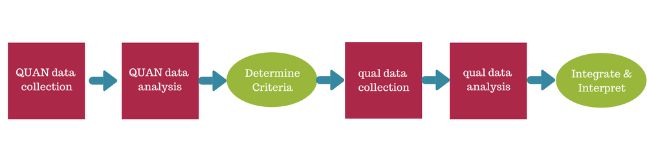
Participants and Sample
Quantitative 25 parents are included in the study. The parents were recruited from on online face book page maintain by the Autism Research Institute that routinely recruits persons for studies on all aspects of Autism Research. The ARI is followed by millions of persons worldwide and will post the results of the study for use by others in the Autism Community. Since on line support groups can be easily accessed it is hoped that the support module will be replicated also as an ongoing Community of Practice to help families cope with their child’s challenges over their lifetime. Participants must be over 18 years of age currently have a child with an ASD diagnosis between the age of 3 and 21 years old. Since the group is online there is no geographic limitation except that all participants should be from the United States. Parents of both boys and girls with ASD were recruited. While there is no compensation monetarily all participants who complete the course will be given a Certificate by the Autism Society of Minnesota
The study will use Purposive Sampling – looking for parents who have children with ASD
Qualitative The same 25 parents recruited for the study will be given a semi-structured interview. A One Group Design will be used for Qualitative data where the researcher will ask questions and observe the participants. The sessions will be recorded and the participants will have an opportunity to answer the questions in writing. The semi-structured interviews will be arranged outside of the weekly group sessions but will be conducted on line using Skype; they will be recorded on video and audiotaped. The schedule will begin Week one and Conclude Week 8. The night of the last session additional open-ended questions on the participant’s attitudes about the program will be administered to all present. Questionnaire responses will be coded to pair the responder’s two interviews.
Pretest and Post test One Group - Group Design Group
1 Obs TX 2 Obs

Instruments
Three Quantitative instruments will be used. Tests can be self administered or offered by person with a Master of Arts in psychology or education.
Demographic Information – Provided from Beck‘s report
Becks Inventory for Depression - 5 minutes given to persons 13-80 years
Researcher will purchase scan able forms from Pearson Q-report, which will score the test and allow progress report for both Beck indexes.
Becks Inventory for Anxiety 21 questions
Purpose Measuring Anxiety Level 17-80 years of age
5-10 minutes administer time

Autism Parent Stress Index Psychometrics:
“The overall APSI scale score demonstrates acceptable internal consistency and test–retest stability for parents of children with autism and other developmental disabilities (Silva & Schalock, 2012).”
The results of the Q-report will be entered into Excel or SPSS software for IBM along with the data from the APSI index. In Beck’s case Pearson Q-report will measure the first test and the second test for both confidence interval based on the first test and give a clinical outcome ranking from negative to optimal. This information will be helpful when we pair the participant’s outcomes on these surveys with themes developed by their responses on the qualitative open ended interviews
Other factors to consider are validity both internal and external validity of the research which internal allow us to draw conclusions. In this case triangulation is used from quantitative and qualitative to justify the conclusions warranted.
As to the external validity the conclusions can be applied to other situations beyond this one case and the online support program replicated which we hope to replicate for other parents support.
The researcher will be ethical and truthful in all dealings and respect the participant’s rights to privacy. After the interpretation of results is concluded any identifying information will be removed.
Online training modules:
The Autism Society of Minnesota will facilitate the on line support program by providing these subjects during the two hour support sessions. The first session the pretest surveys will be administered, the last session the posttest survey will be administered. On completion the AUSM will issue certificates of successful completion of the online training program. Domain will range from 3-25
Week 1 Pretest and Autism - -Qualitative Interviews (3)
Week 2 Autism and Communication - Qualitative Interviews (4)
Week 3 Autism and Sensory experiences – Qualitative Interview (4)
Week 4 Autism Stress and Anxiety- Qualitative Interviews (4)
Week 5 Supporting Families- Qualitative Interviews (4)
Week 6 Autism Sport and Physical activity –Qualitative Interviews (4)
Week 7 Autism and Safety Issues, Water, Police and Wandering-Qualitative Interviews (3)
Week 8 Posttest and Qualitative Interviews on Course (25)
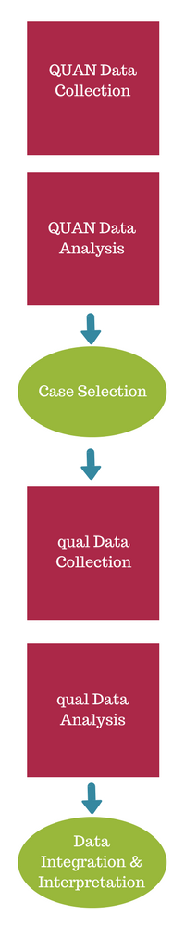
Phase 1 Design Study

Phase 2 Recruit Particpants

Phase 3 Conduct research

Phase 4 Analyze Data

Phase 5 Interpret results

Phase 6 Prepare report

Procedures Survey Pre and Post tests
Procedures Semi Structured Interviews
Mixed Methods Research
Mixed methods research is described by Creswell (2014) as the process of intergrating qualitative and quanitative research and data in a research study (page 14). One method is Convergent parallel mixed methods
Convergent Design Quan and Qual are complimentary during data collection and data analysis or both . The primary reason for using this method is to triangulate the quanitative and qualitative data to support the findings of each therefore counteracting the weaknesses of each approach (page 15)
The two data sets will be collected separately and analyzed separately. The expected outcomes are presented in a fashion to support each other or show how they are divergent. (p231) In this case data will be collected during the course of the 8 week training online session so it is concurrent. Collection of data for each strand is independent and does not rely the other to be collected. Similarly the weight attached to each strand is equal with neither method taking priority. In this case the quantitative and qualitative data will be used to complement, support and help explain the research question. Issues of the timing and weighting are central to this design method. Two data sets are collected independently and the merging the two data bases allows the researcher to show how data converges or is diverse (Creswell)
A notation system is used to describe the data ( QUAN + QUAL data (Morse 1991) indicates the two strands are treated with equal weight.
The resultant report will show presentation of each Side by side comparison will take place within the discussion of the findings . Given the human complexity of parents dealing with ASD indicators of stress, anxiety, and the themes that evolve from the semi structured interviews lend themselves to this approach as more information can be gathered to to understand the phenomena. The validity of this method (construct) and (triangulation) bringing in other sources of data that allows for validation.
Quantitative data collection.
- 25 participants
- Self identified as parents of children 3-21 with an ASD diagnosis
- Recruited online from ARI face book page
- Demographic information will be collected for sorting of variables
- Survey information will be collected to answer each research question
Qualitative data collection.
- 25 participants in the study recruited will be given semi structure open ended questions to determine more in depth information. This survey will be administered throughout the 8 week program with additional open ended questions being asked the last week of the online program and will be conducted by Skype, the results will be audio recorded as well as transcribed from written responses
- Open-ended survey, audio-visual responses.

Data analysis
Analysis was separate sources of evidence which were lined up and compared during data analysis each interview was coded using software program line by line. Online Q- scoring from Pearson and SPSS was used for quantitative data
Coding of interviews will begin on veracity of transcript. The program being used is MAXDA. The steps are read the data from the research question responses Coding segments of the text, establish categories (themes), analyze data, and present results. Priority convergent method QUAN + QUAL (Morse, 1991)
The data will be reviewed and verified after verifying the responses will be coded line by line using methods discussed above. After the themes are established, Excel spread sheets or SPSS will be utilized to pair responses from the participants and determine correlation between parents who experienced depression or anxiety, and their themes. A similar presentation will be done for parents who did not exhibit anxiety or depression. Inferences will be drawn from this pairing to answer the mixed methods research question.
Presentation of findings
Several methods will be used to present finding
Likert charts for Three Instruments (Quantatative)
Instrument Title: Autism Parenting Stress Index (APSI) 0-65
Becks Anxiety Index
Becks Depression Index

Likert Type Chart
I’d recommend a smart home to (15 people surveyed | Strongly agree | Agree | Neutral | Disagree | Strongly disagree | No opinion
Questions in index | 6 | 3 | 1 | 2 | 2 | 1
Findings  Keyed to each scale  In instrument | 3 | 1 | 1 | 1 | 6 | 3

Qualitative will use Tables and Descriptive Discussion
Survey questions will be tabulated and presented in table of findings including categories such as Appropriateness of topics, Helpfulness of being in group
Most helpful, Least helpful, Additional topics.Would you mentor someone else?

Table 2
Comparison of Prescale and Postscale score on Beck Index for Depression and Anxiety
(N) = 25 Pretest Posttest Significance
Depression 12 10 p<
Anxiety 23 17 p<

Table 3
Instrument Author No of domains Format Questionnaire Scoring
Beck Anxiety Beck 21 Likert 0-63
Beck Depression Beck 21 Likert 0-63
APSI Silva, L. M. T., & Schalock 13 Likert 0-65
Higher scores correlate to higher levels of stress/anxiety
Other factors important to study possible outcomes will come from Interviews at Beginning and End of Project
Attitudes towards support, why they have agreed to project?
After interview - explored the process, attitudes towards support, and future subjects
Possible findings-First interview - Themes isolation, fear of unknown, fear of future
Second interview- Better able to cope, less afraid of future, empowered to help others

Mixed methods
Findings Presented
There will be a Correlation of persons who experienced stress/ No stress to more positive outcomes
Pairing of Quan Rating Scale Answers to Themes
Comparison of pre and post test responses to themes
The qualitative data is supported by the quantitative data with a reduction of stress/anxiety and the ability to cope and move more confidently towards the future to deal with their children.

References

Autism Society of Minnesota Conference Proceedings, April 26-29, 2017 http://www.ausm.org/
Banach, M., Iudice, J., Conway, L., & Couse, L. J. (2010). Family Support and Empowerment: Post Autism Diagnosis Support Group for Parents. Social Work With Groups, 33(1), 69-83. doi:10.1080/01609510903437383

Beck, A. T., Epstein, N., Brown, G., Steer, R. A. (1988). An inventory for measuring clinical anxiety: Psychometric properties. Journal of Consulting and Clinical Psychology, 56, 893-897
Beck, A. T, An inventory for measuring depression, http://emedicine.medscape.com/article/1859039-overview
Bray, L., Carter, B., Sanders, C., Blake, L., & Keegan, K. (2017). Parent-to-parent peer support for parents of children with a disability: A mixed method study. Patient Education and Counseling. doi:10.1016/j.pec.2017.03.004
Caruth, G. D. (2013). Demystifying Mixed Methods Research Design: A Review of the Literature. Mevlana International Journal of Education, 3(2), 112-122. doi:10.13054/mije.13.35.3.2
Clark, C. (2011). Parent Consultation Group for Parents of Children with Autism Spectrum Disorder: A Mixed Methodological Study. Online Theses.
http://encompass.eku.edu/etd

Crane, L., Chester, J. W., Goddard, L., Henry, L. A., & Hill, E. (2016). Experiences of autism diagnosis: A survey of over 1000 parents in the United Kingdom. Autism, 20(2), 153-162. doi:10.1177/1362361315573636
Creswell, J. (11-14-2013). Steps in Conducting a Scholarly Mixed Methods Study, [Abstract]. DBER Speaker Series, 48. Retrieved April 4, 2017, from http://digatcommons.unl.edu/48

Creswell J. W., & Plano Clark, V. L. (2010). Designing and conducting mixed
methods research (2nd ed.). Thousand Oaks, CA: Sage.
Creswell, J. W. (2015). Educational research: planning, conducting, and evaluating quantitative and qualitative research. Boston: Pearson.
Daneback, K., & Plantin, L. (2008). Research on Parenthood and the Internet:Themes and Trends [Abstract]. Pyschosocial Research on Cyberspace, 2(2), 1-10.
DeCuir-Gunby, J. T., & Schutz, P. A. (2017). Developing a mixed methods proposal: a practical guide for beginning researchers. Thousand Oaks: SAGE Publications, Inc.
Dehoff, B. A., Staten, L. K., Rodgers, R. C., & Denne, S. C. (2016). The Role of Online Social Support in Supporting and Educating Parents of Young Children With Special Health Care Needs in the United States: A Scoping Review. Journal of Medical Internet Research, 18(12). doi:10.2196/jmir.6722
Hall, H. R., Neely-Barnes, S. L., Graff, J. C., Krcek, T. E., Roberts, R. J., & Hankins, J. S. (2012). Parental Stress in Families of Children with a Genetic Disorder/Disability and the Resiliency Model of Family Stress, Adjustment, and Adaptation. Issues in Comprehensive Pediatric Nursing, 35(1), 24-44. doi:10.3109/01460862.2012.646479
K. (n.d.). KFM Making A Difference on WordPress.com. Retrieved April 16, 2017, from https://kfmmakingadifference.org/
Kroll, T., & Neri, M. (2009). Designs for Mixed Methods Research. Mixed Methods Research for Nursing and Health Sciences, 31-49.
Mackintosh, V., Myers, B., & Goin-kochel, R. (n.d.). Sources of Information and support used by parents of children with Autism Spectrum Disorders. Jounral of Developmental Disabilities, 12(1).
Pluye, P., & Hong, Q. N. (2014). Combining the Power of Stories and the Power of Numbers: Mixed Methods Research and Mixed Studies Reviews. Annual Review of Public Health, 35(1), 29-45. doi:10.1146/annurev-publhealth-032013-182440
Searing, B. M., Graham, F., & Grainger, R. (2015). Support Needs of Families Living with Children with Autism Spectrum Disorder. Journal of Autism and Developmental Disorders, 45(11), 3693-3702. doi:10.1007/s10803-015-2516-4
Silva, L. M. T., & Schalock, M. (2012). Autism parenting stress index: Initial psychometric evidence. Journal of Autism and Developmental Disorders, 42, 566-574.
Webster, A. A., Cumming, J., & Rowland, S. (2017). Empowering parents of children with autism spectrum disorder: critical decision-making for quality outcomes. Singapore: Springer.
Zimmerman, E. (2013). A Pilot Study Exploring the Educational and Social/Emotional Benefits of Web-based Groups for Parents of Adolescents with Autism Spectrum Disorder [Abstract]. Proquest Dissertations.

Additional Previous References
(n.d.). Retrieved April 14, 2017, from http://acn-sa.org/
(n.d.). Retrieved April 14, 2017, from https://www.sciencedaily.com/releases/2016/04/160406124631.htm
100 Day Kit. (n.d.). Retrieved April 16, 2017, from http://www.autismspeak.org/
Autism and Parent Support Groups. (2014, September 05). Retrieved April 16, 2017, from http://theautismblog.seattlechildrens.org/autism-and-parent-support-groups/
Autism Discussion Page. (n.d.). Retrieved April 16, 2017, from https://www.facebook.com/pg/autismdiscussionpage/about/?ref=page_internal
Barber, C. (2009). Life and learning with autistic spectrum disability
Brown, N. E. (n.d.). Social Skills Training: A Parent Education Program for Culturally Diverse Parents of Children with Autism Spectrum Disorders.
Informal learning: theory, practice and experience. (2014, July 09). Retrieved April 16, 2017, from http://infed.org/mobi/informal-learning-theory-practice-and-experience/
Lave, J., & Wenger, E. (1998). Situated learning: legitimate peripheral participation. Cambridge: Cambridge University Press.
Macintyre, C. (2016). Strategies to support children with autism and other complex needs: resources for teachers, support staff and parents. London: Routledge, is an imprint of the Taylor & Francis Group, an Informal business.
Study Introduction Letter Template For Participants. (n.d.). Retrieved from https://www.seattlechildrens.org/doc/study-introduction-letter-template-for-parttps:
Understanding. (n.d.). Retrieved April 14, 2017, from https://theautismcommunity.org/
Webster, A. A., Cumming, J., & Rowland, S. (2017). Empowering parents of children with autism spectrum disorder: critical decision-making for quality outcomes. Singapore: Springer.
Wenger, E. (2008). Communities of practice: learning, meaning, and identity. Cambridge: Cambridge University Press.

Appendix A 1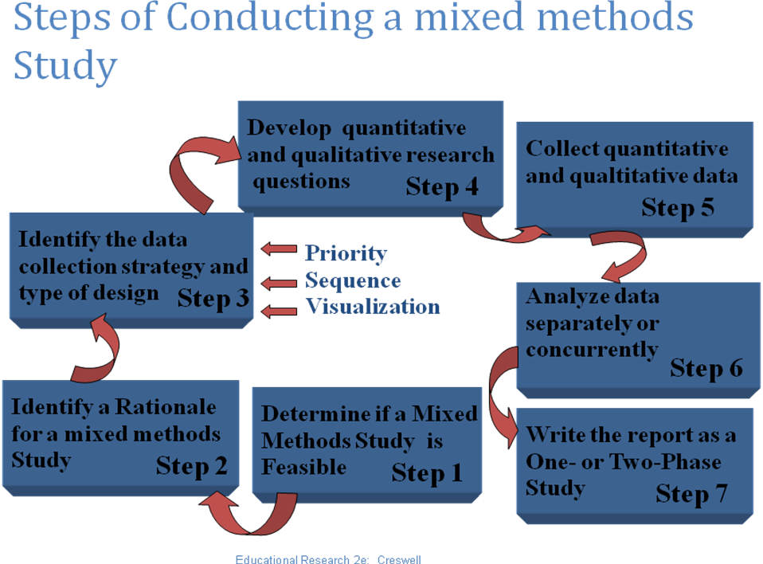

Creswell, Educational Research 2e

Appendix A .2
Survey Instruments
All three instruments are copyrighted and available to the public. The Beck’s surveys will be purchased from Pearson. The ASPI is available free of charge.
Instrument Title: Autism Parenting Stress Index (APSI)
Instrument Author: Silva, L. M. T., & Schalock, M.
Cite instrument as: Silva, L. M. T., & Schalock, M. . (2012) . Autism
Parenting Stress Index (APSI) . Measurement
Instrument Database for the Social Science.
Retrieved from www.midss.ie
Date: Name of child: Person completing checklist:_________________ Autism Parenting Stress Index

Stress Ratings
Please rate the following aspects of your child’s health according to how much stress it causes you and/or your family by placing an X in the box that best describes your situation. Not stressful
Sometimes creates stress
Often creates stress
Very stressful on a daily basis
So stressful sometimes we feel we can’t cope
Your child’s social development 0 1 2 3 5
Your child’s ability to communicate 0 1 2 3 5
Tantrums/meltdowns 0 1 2 3 5
Aggressive behavior (siblings, peers) 0 1 2 3 5
Self-injurious behavior 0 1 2 3 5
Difficulty making transitions from one activity to another 0 1 2 3 5
Sleep problems 0 1 2 3 5
Your child’s diet 0 1 2 3 5
Bowel problems (diarrhea, constipation) 0 1 2 3 5
Potty training 0 1 2 3 5
Not feeling close to your child 0 1 2 3 5
Concern for the future of your child being accepted by others 0 1 2 3 5
Concern for the future of your child living independently 0 1 2 3 5
Subtotal Total

Beck’s Anxiety Index

This work is licensed under the Creative Commons, http://creativecommons.org/licenses/by-ncnd/3.0. © LMTSilva Nov. 2011. This instrument is protected by copyright; it may not be altered or sold. Permission is granted for duplication free of charge. Qigong Sensory Training Institute, www.qsti.org

Beck's Depression Inventory
This depression inventory can be self-scored. The scoring scale is at the end of the questionnaire.
.
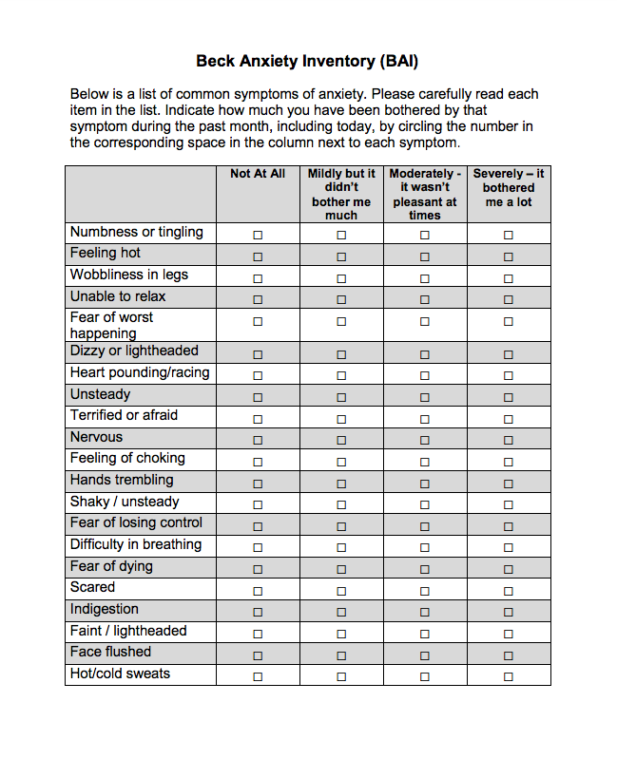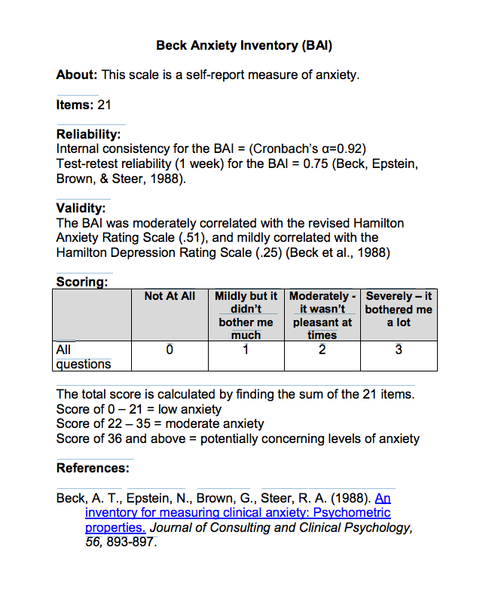
Date: Name of child: Person completing checklist:_________________
Autism Parenting Stress Index
Stress Ratings
Please rate the following aspects of your child’s health according to how much stress it causes you and/or your family by placing an X in the box that best describes your situation.
Not stressful
Sometimes creates stress
Often creates stress
Very stressful on a daily basis
So stressful sometimes we feel we can’t cope
Your child’s social development
0
1
2
3
5
Your child’s ability to communicate
0
1
2
3
5
Tantrums/meltdowns
0
1
2
3
5
Aggressive behavior (siblings, peers)
0
1
2
3
5
Self-injurious behavior
0
1
2
3
5
Difficulty making transitions from one activity to another
0
1
2
3
5
Sleep problems
0
1
2
3
5
Your child’s diet
0
1
2
3
5
Bowel problems (diarrhea, constipation)
0
1
2
3
5
Potty training
0
1
2
3
5
Not feeling close to your child
0
1
2
3
5
Concern for the future of your child being accepted by others
0
1
2
3
5
Concern for the future of your child living independently
0
1
2
3
5
Subtotal
Total

Participation Forms (This form was rewritten using examples previously noted)
May 1, 2017
Dear Ms. Smith
My name is Kerry Magro. I am a doctoral candidate at New Jersey City University located in Jersey City, New Jersey. I am currently conducting a research study on Online Support Groups for Parents of Autistic Children.
I am contacting you because you responded to an email sent by Autism Research Institute to be part of this study. Our research centers on parent’s of autistic children who experience a lot of stress during the diagnoses process and afterward. The Autism Society of Minnesota has developed a comprehensive program of parental support. This would be the first time the program would be offered as an online program. On line education and creation of Communities of Place support has helped many parents deal with their stress. You are being invited to participate in an eight week online support and education program being run by the Austism Society of Minnesota. The researcher would administer pre and post tests on your experiences with your child diagnoses, your stress and anxiety concerning your child. After amd during the eight weeks of online training and support the researcher will administer on line open ended semi structured interviews.
Your experiences can help us understand this issue better and contribute to making a difference in the lives of other parent with children with autism. You are under no obligation to participate.
We are looking for parents :
- 18 years old or older
  - Have a child with an ASD diagnosis 3-21 Willing to participate in the program which will take place over four months including an online support program for 8 weeks
- The sessions may be audio recorded
- Willing to fill out questionnaires before the training and at the conclusion of the training
- Will to participate in open ended semi structured interviews
- Your individual participation (name) will be kept confidential;
The interviews will be conducted online at a time convenient for you. The study will answer the question of whether you were assisted by the training sessions and participation in the support group. After the interview, the researcher will send you a copy of a transcript for you to verify that the researcher caught what you said accurately. Your information will be kept confidential. There will be no names in the findings. There is no cost to participate in the study. If you are still interested you may reach me by email at kerrymagro@gmail.com. Please let me know if you have any questions. You can also call me at 201-360-7819. Taking part in research is voluntary. You will not be compensated monetarily. However, you will receive a Certificate from the Autism Society of Minnesota on the training program’ s completion. Your participation can help make a difference in your life and the lives of other parents with children on the spectrum.
Thank you for your time.

Sincerely,

Kerry Magro, MA
New Jersey City University
Doctoral Candidate
kerrymagro@gmail.com
Study Introduction Letter Template For Participants. (n.d.). Retrieved from https://www.seattlechildrens.org/doc/study-introduction-letter-template-for-parttps://www.seattlechildrens.org/doc/study-introduction-letter-template-for-part

If I have questions about the research and my rights as a research volunteer, I may contact Dr. Christopher Canaharan, IRB Chair, NJCU, JCNJ 07305 or @njcu.edu

Participant Rights: I understand that my participation is voluntary. There is no penalty for refusal to participate, and I am free to withdraw my consent and participation in this study at any time without any penalty. Signatures: I have read and fully understand the consent form. I sign it freely and voluntarily. A copy of this form has been given to me. ________________________ _______________ Signature of Participant D

